**[1\_shell](https://github.com/JanDeDobbeleer/oh-my-posh/blob/main/themes/1_shell.omp.json" \o "1_shell" \t "_blank)**[**​**](https://ohmyposh.dev/docs/themes#1_shell)

[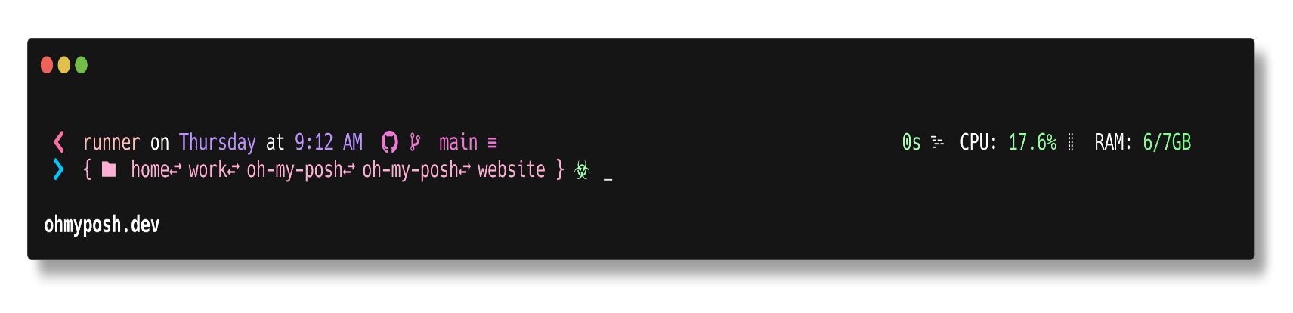](https://github.com/JanDeDobbeleer/oh-my-posh/blob/main/themes/1_shell.omp.json)

[**M365Princess**](https://github.com/JanDeDobbeleer/oh-my-posh/blob/main/themes/M365Princess.omp.json)[**​**](https://ohmyposh.dev/docs/themes#m365princess)

[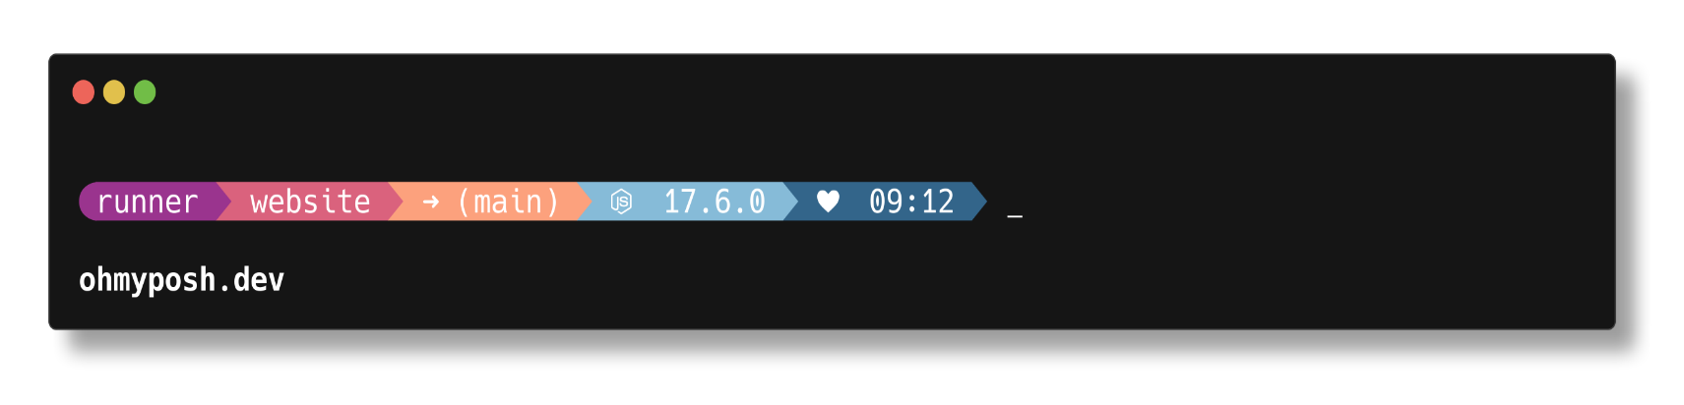](https://github.com/JanDeDobbeleer/oh-my-posh/blob/main/themes/M365Princess.omp.json)

[**agnoster.minimal**](https://github.com/JanDeDobbeleer/oh-my-posh/blob/main/themes/agnoster.minimal.omp.json)[**​**](https://ohmyposh.dev/docs/themes#agnosterminimal)

[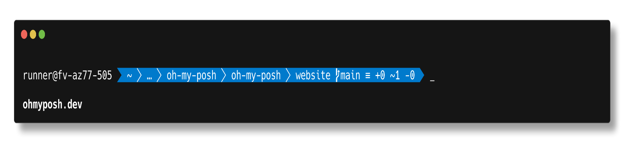](https://github.com/JanDeDobbeleer/oh-my-posh/blob/main/themes/agnoster.minimal.omp.json)

[**agnoster**](https://github.com/JanDeDobbeleer/oh-my-posh/blob/main/themes/agnoster.omp.json)[**​**](https://ohmyposh.dev/docs/themes#agnoster)

[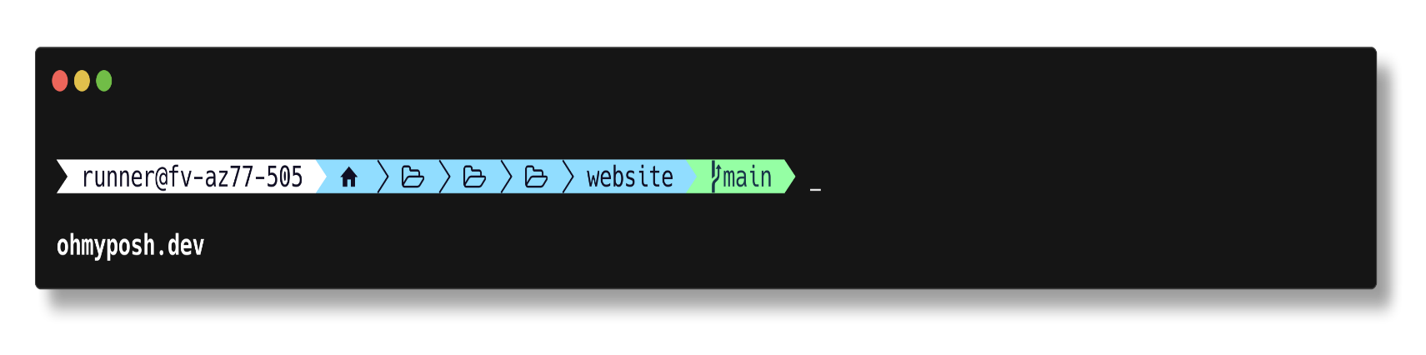](https://github.com/JanDeDobbeleer/oh-my-posh/blob/main/themes/agnoster.omp.json)

[**agnosterplus**](https://github.com/JanDeDobbeleer/oh-my-posh/blob/main/themes/agnosterplus.omp.json)[**​**](https://ohmyposh.dev/docs/themes#agnosterplus)

[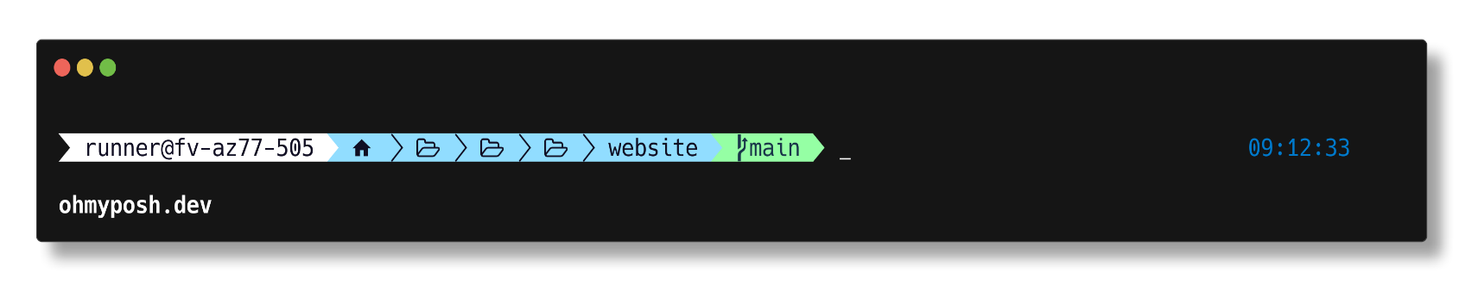](https://github.com/JanDeDobbeleer/oh-my-posh/blob/main/themes/agnosterplus.omp.json)

[**aliens**](https://github.com/JanDeDobbeleer/oh-my-posh/blob/main/themes/aliens.omp.json)[**​**](https://ohmyposh.dev/docs/themes#aliens)

[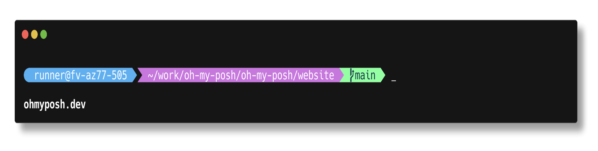](https://github.com/JanDeDobbeleer/oh-my-posh/blob/main/themes/aliens.omp.json)

[**amro**](https://github.com/JanDeDobbeleer/oh-my-posh/blob/main/themes/amro.omp.json)[**​**](https://ohmyposh.dev/docs/themes#amro)

[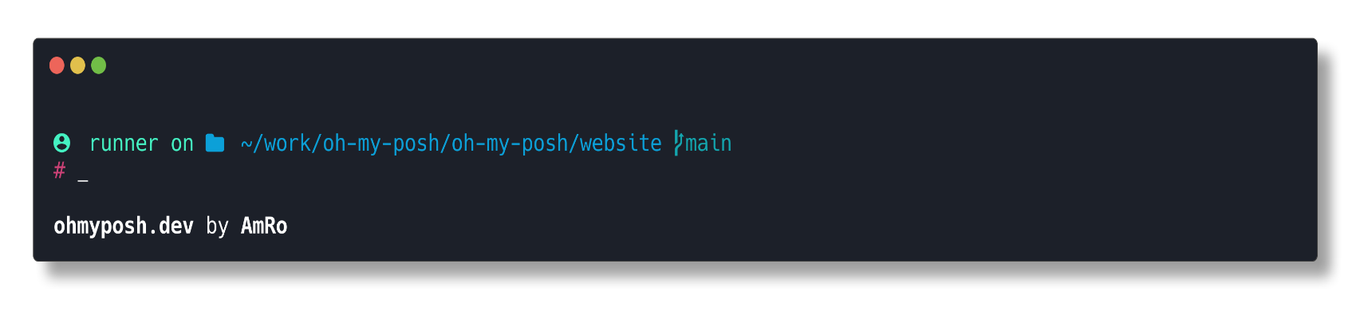](https://github.com/JanDeDobbeleer/oh-my-posh/blob/main/themes/amro.omp.json)

[**atomic**](https://github.com/JanDeDobbeleer/oh-my-posh/blob/main/themes/atomic.omp.json)[**​**](https://ohmyposh.dev/docs/themes#atomic)

[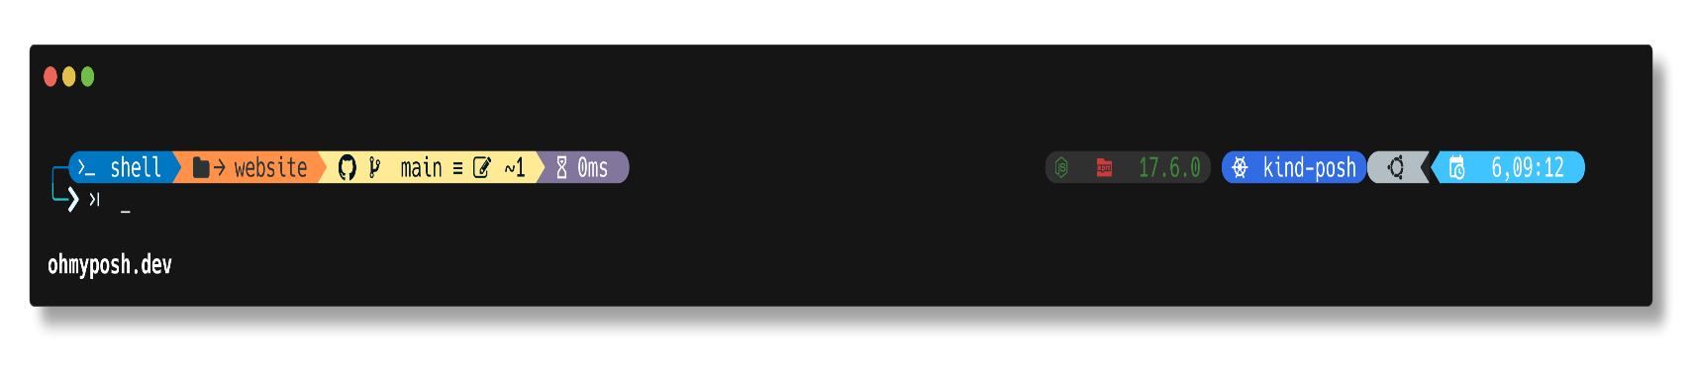](https://github.com/JanDeDobbeleer/oh-my-posh/blob/main/themes/atomic.omp.json)

[**atomicBit**](https://github.com/JanDeDobbeleer/oh-my-posh/blob/main/themes/atomicBit.omp.json)[**​**](https://ohmyposh.dev/docs/themes#atomicbit)

[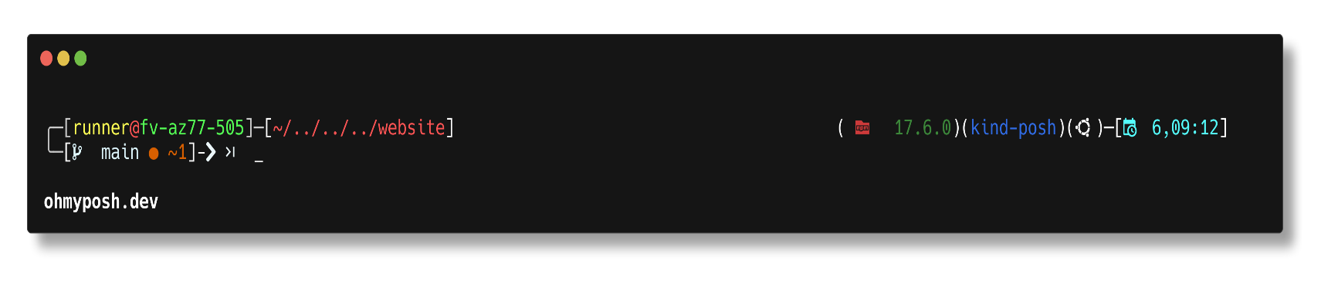](https://github.com/JanDeDobbeleer/oh-my-posh/blob/main/themes/atomicBit.omp.json)

[**avit**](https://github.com/JanDeDobbeleer/oh-my-posh/blob/main/themes/avit.omp.json)[**​**](https://ohmyposh.dev/docs/themes#avit)

[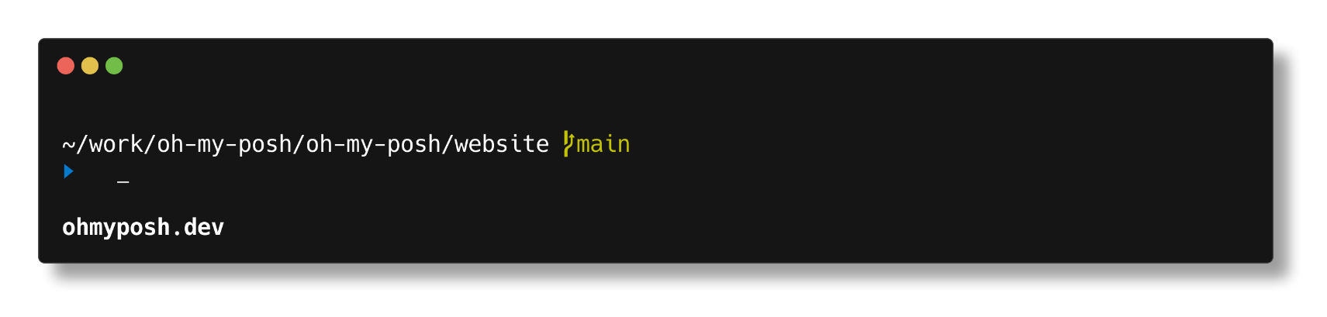](https://github.com/JanDeDobbeleer/oh-my-posh/blob/main/themes/avit.omp.json)

[**blue-owl**](https://github.com/JanDeDobbeleer/oh-my-posh/blob/main/themes/blue-owl.omp.json)[**​**](https://ohmyposh.dev/docs/themes#blue-owl)

[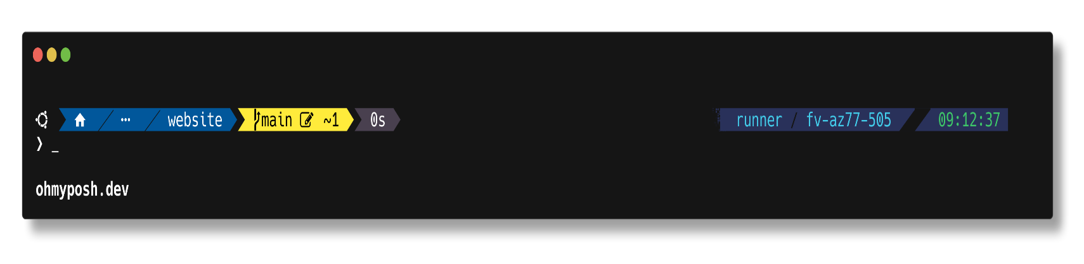](https://github.com/JanDeDobbeleer/oh-my-posh/blob/main/themes/blue-owl.omp.json)

[**blueish**](https://github.com/JanDeDobbeleer/oh-my-posh/blob/main/themes/blueish.omp.json)[**​**](https://ohmyposh.dev/docs/themes#blueish)

[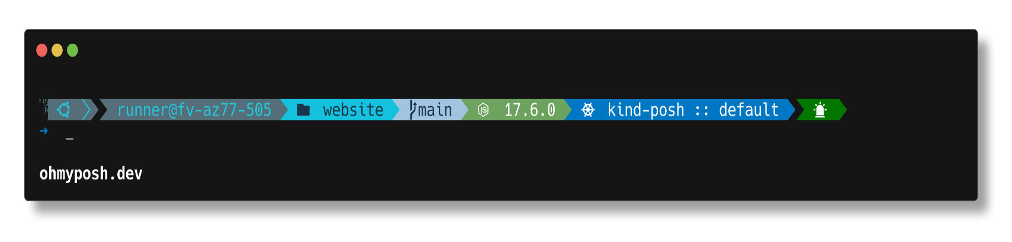](https://github.com/JanDeDobbeleer/oh-my-posh/blob/main/themes/blueish.omp.json)

[**bubbles**](https://github.com/JanDeDobbeleer/oh-my-posh/blob/main/themes/bubbles.omp.json)[**​**](https://ohmyposh.dev/docs/themes#bubbles)

[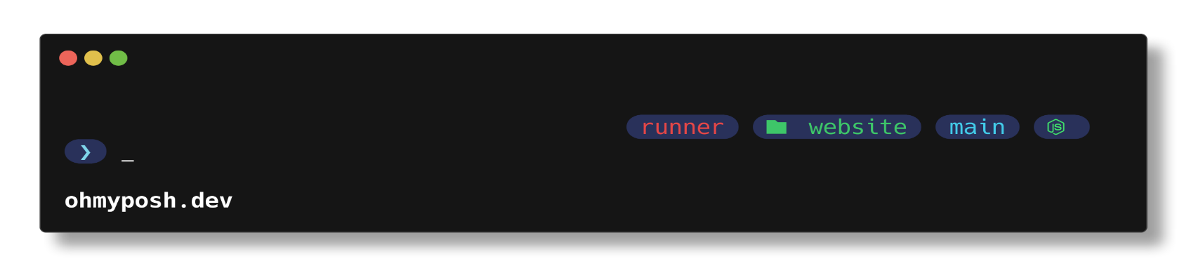](https://github.com/JanDeDobbeleer/oh-my-posh/blob/main/themes/bubbles.omp.json)

[**bubblesextra**](https://github.com/JanDeDobbeleer/oh-my-posh/blob/main/themes/bubblesextra.omp.json)[**​**](https://ohmyposh.dev/docs/themes#bubblesextra)

[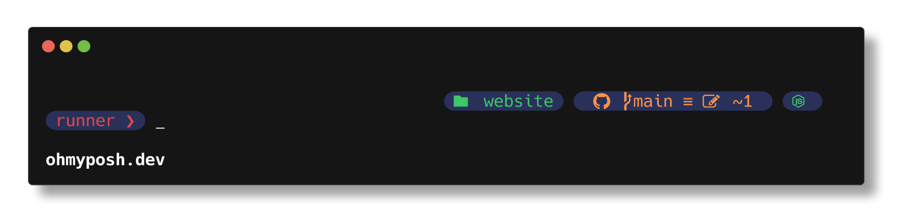](https://github.com/JanDeDobbeleer/oh-my-posh/blob/main/themes/bubblesextra.omp.json)

[**bubblesline**](https://github.com/JanDeDobbeleer/oh-my-posh/blob/main/themes/bubblesline.omp.json)[**​**](https://ohmyposh.dev/docs/themes#bubblesline)

[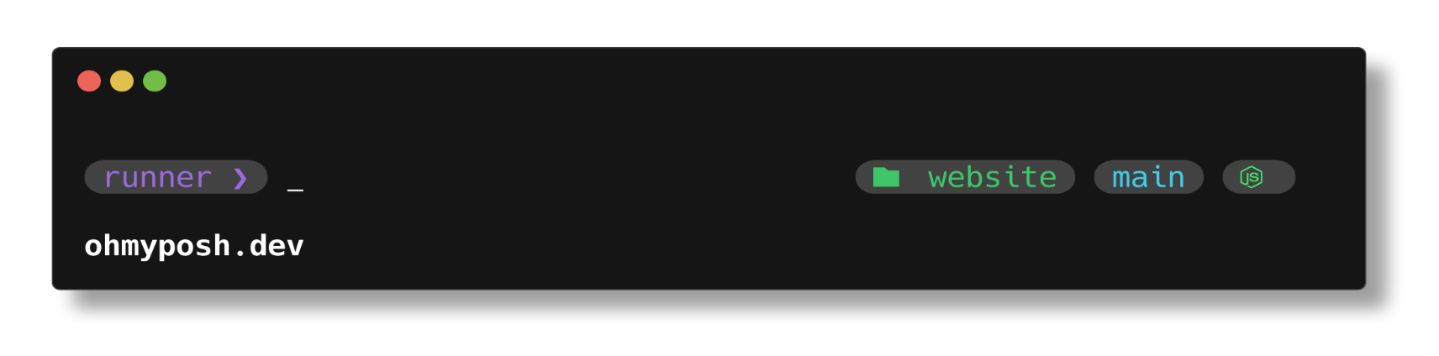](https://github.com/JanDeDobbeleer/oh-my-posh/blob/main/themes/bubblesline.omp.json)

[**capr4n**](https://github.com/JanDeDobbeleer/oh-my-posh/blob/main/themes/capr4n.omp.json)[**​**](https://ohmyposh.dev/docs/themes#capr4n)

[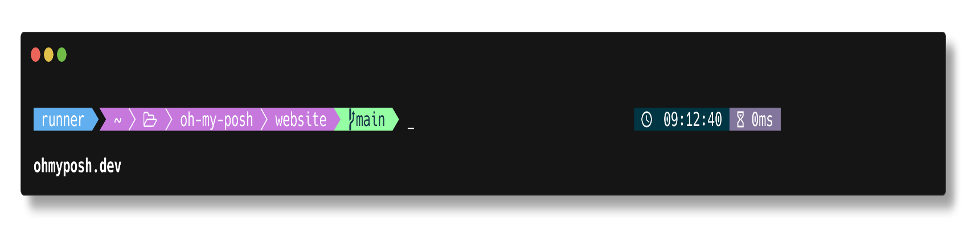](https://github.com/JanDeDobbeleer/oh-my-posh/blob/main/themes/capr4n.omp.json)

[**catppuccin**](https://github.com/JanDeDobbeleer/oh-my-posh/blob/main/themes/catppuccin.omp.json)[**​**](https://ohmyposh.dev/docs/themes#catppuccin)

[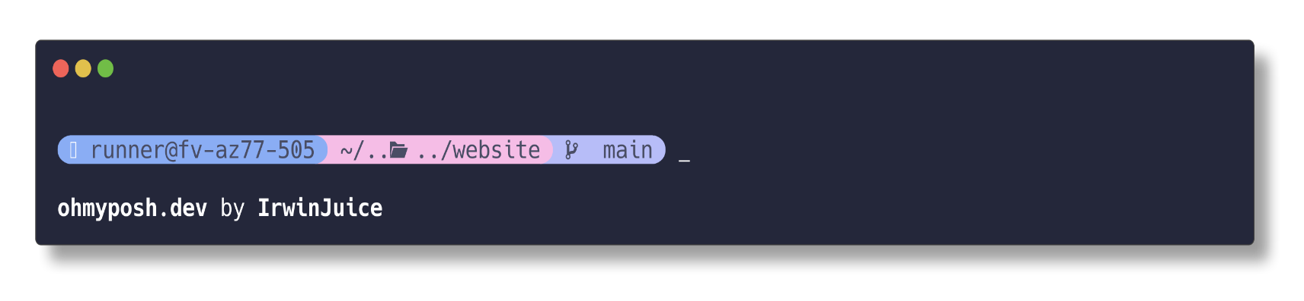](https://github.com/JanDeDobbeleer/oh-my-posh/blob/main/themes/catppuccin.omp.json)

[**catppuccin\_frappe**](https://github.com/JanDeDobbeleer/oh-my-posh/blob/main/themes/catppuccin_frappe.omp.json)[**​**](https://ohmyposh.dev/docs/themes#catppuccin_frappe)

[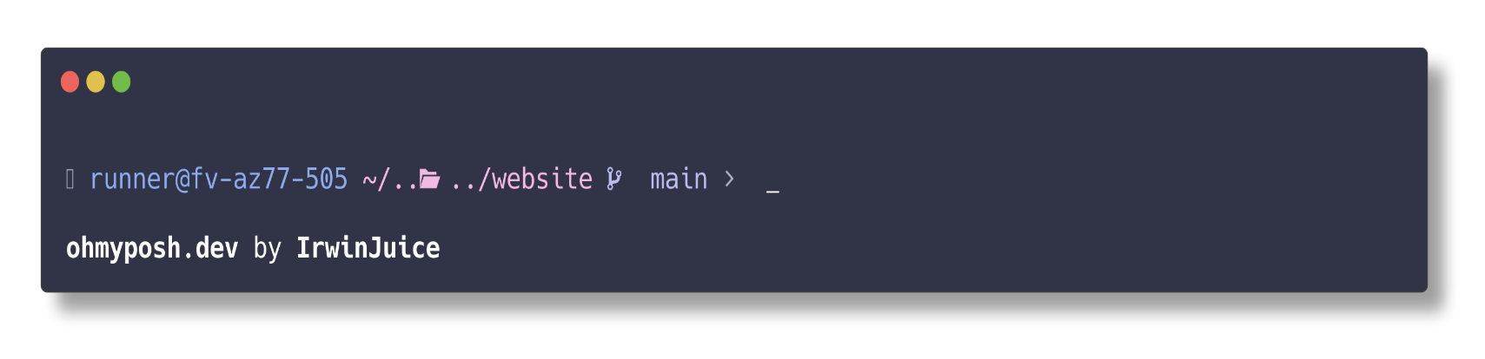](https://github.com/JanDeDobbeleer/oh-my-posh/blob/main/themes/catppuccin_frappe.omp.json)

[**catppuccin\_latte**](https://github.com/JanDeDobbeleer/oh-my-posh/blob/main/themes/catppuccin_latte.omp.json)[**​**](https://ohmyposh.dev/docs/themes#catppuccin_latte)

[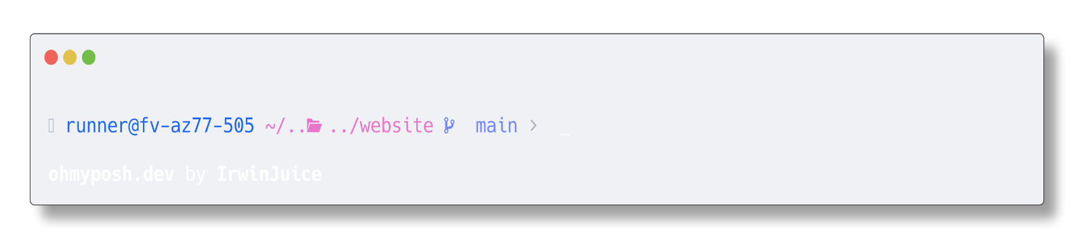](https://github.com/JanDeDobbeleer/oh-my-posh/blob/main/themes/catppuccin_latte.omp.json)

[**catppuccin\_macchiato**](https://github.com/JanDeDobbeleer/oh-my-posh/blob/main/themes/catppuccin_macchiato.omp.json)[**​**](https://ohmyposh.dev/docs/themes#catppuccin_macchiato)

[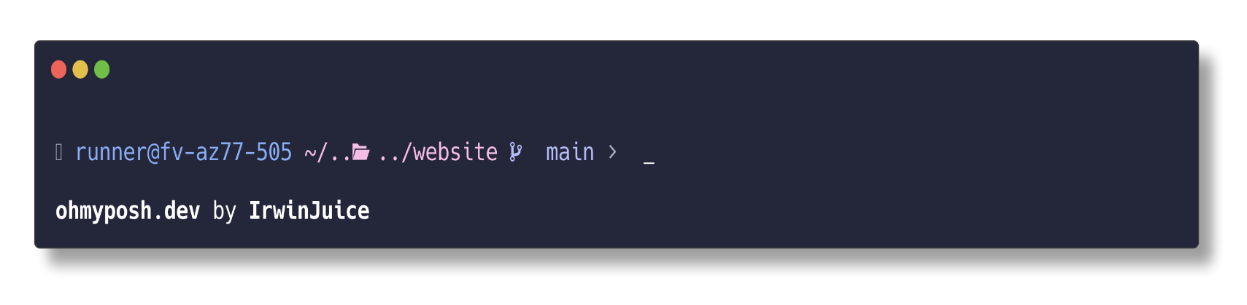](https://github.com/JanDeDobbeleer/oh-my-posh/blob/main/themes/catppuccin_macchiato.omp.json)

[**catppuccin\_mocha**](https://github.com/JanDeDobbeleer/oh-my-posh/blob/main/themes/catppuccin_mocha.omp.json)[**​**](https://ohmyposh.dev/docs/themes#catppuccin_mocha)

[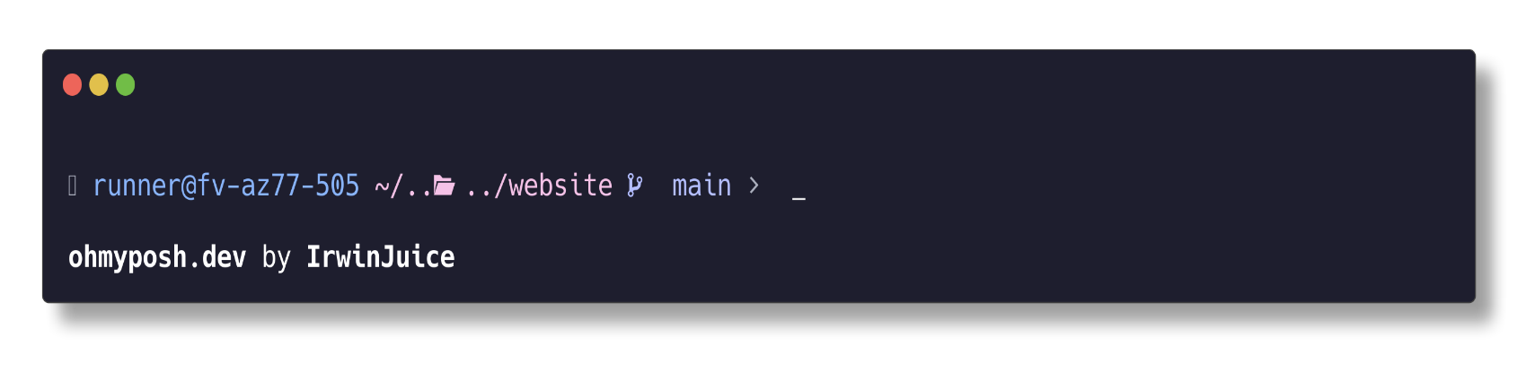](https://github.com/JanDeDobbeleer/oh-my-posh/blob/main/themes/catppuccin_mocha.omp.json)

[**cert**](https://github.com/JanDeDobbeleer/oh-my-posh/blob/main/themes/cert.omp.json)[**​**](https://ohmyposh.dev/docs/themes#cert)

[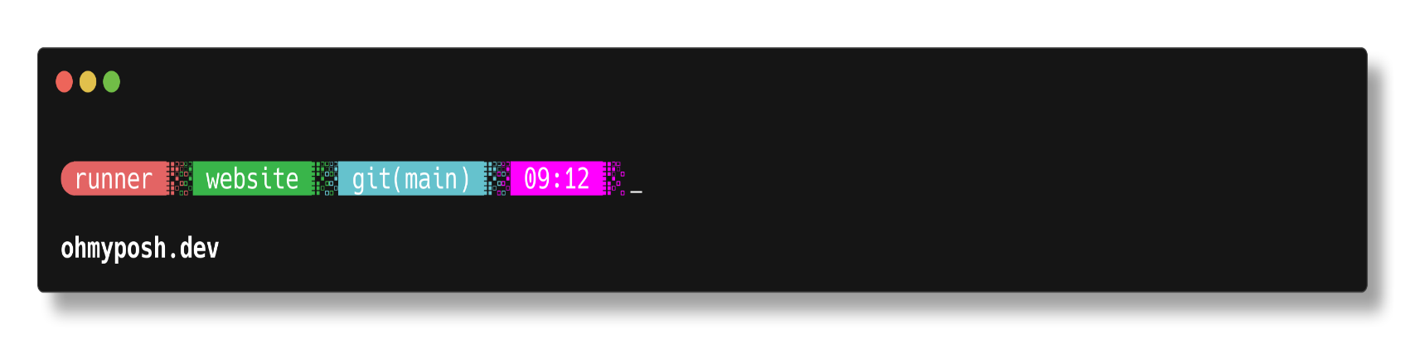](https://github.com/JanDeDobbeleer/oh-my-posh/blob/main/themes/cert.omp.json)

[**chips**](https://github.com/JanDeDobbeleer/oh-my-posh/blob/main/themes/chips.omp.json)[**​**](https://ohmyposh.dev/docs/themes#chips)

[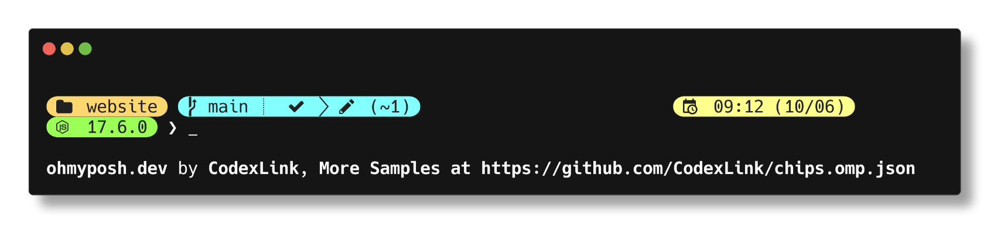](https://github.com/JanDeDobbeleer/oh-my-posh/blob/main/themes/chips.omp.json)

[**cinnamon**](https://github.com/JanDeDobbeleer/oh-my-posh/blob/main/themes/cinnamon.omp.json)[**​**](https://ohmyposh.dev/docs/themes#cinnamon)

[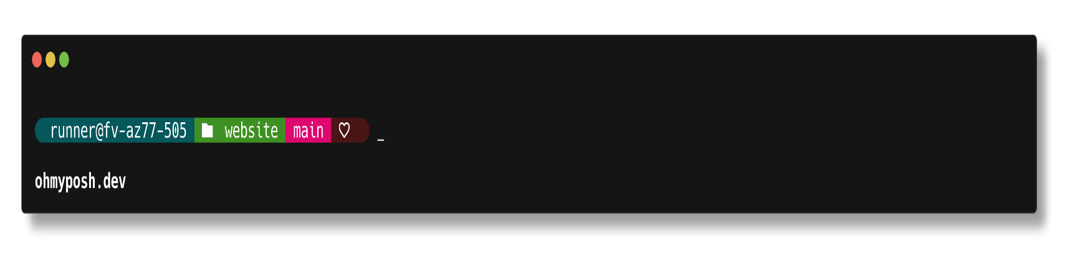](https://github.com/JanDeDobbeleer/oh-my-posh/blob/main/themes/cinnamon.omp.json)

[**clean-detailed**](https://github.com/JanDeDobbeleer/oh-my-posh/blob/main/themes/clean-detailed.omp.json)[**​**](https://ohmyposh.dev/docs/themes#clean-detailed)

[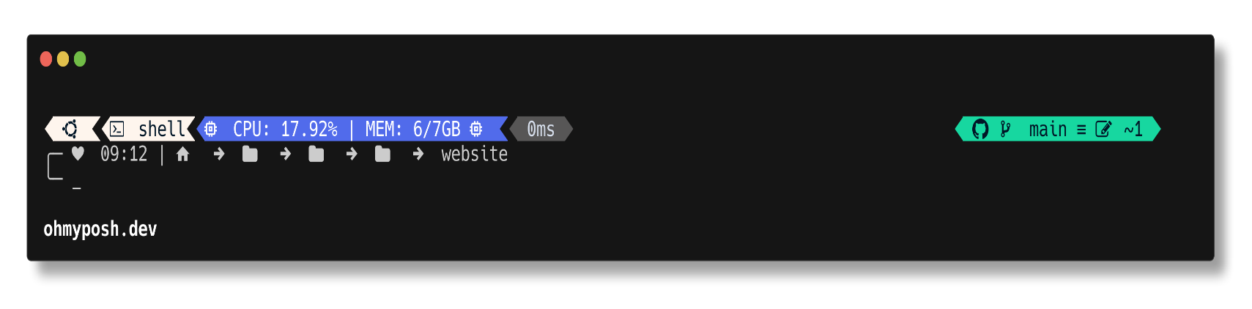](https://github.com/JanDeDobbeleer/oh-my-posh/blob/main/themes/clean-detailed.omp.json)

[**cloud-context**](https://github.com/JanDeDobbeleer/oh-my-posh/blob/main/themes/cloud-context.omp.json)[**​**](https://ohmyposh.dev/docs/themes#cloud-context)

[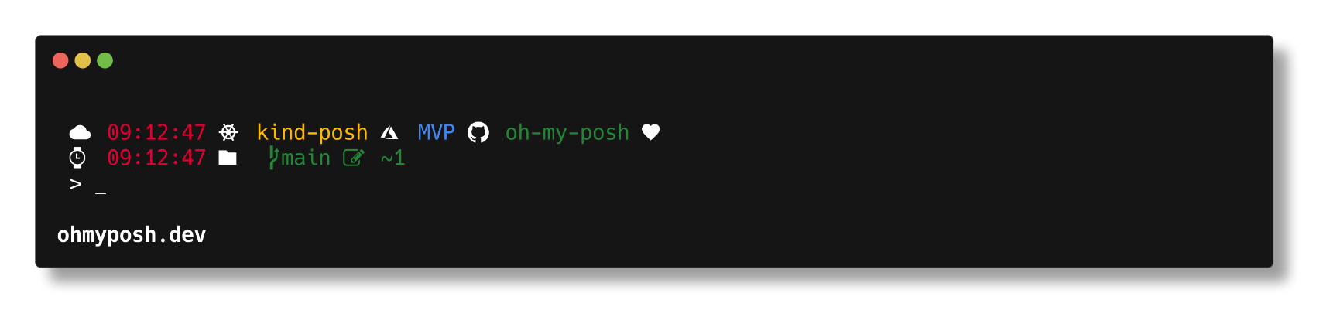](https://github.com/JanDeDobbeleer/oh-my-posh/blob/main/themes/cloud-context.omp.json)

[**cloud-native-azure**](https://github.com/JanDeDobbeleer/oh-my-posh/blob/main/themes/cloud-native-azure.omp.json)[**​**](https://ohmyposh.dev/docs/themes#cloud-native-azure)

[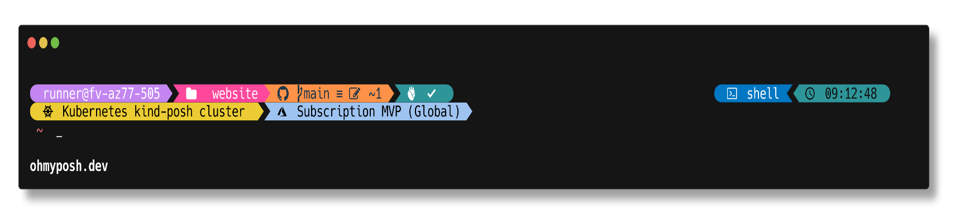](https://github.com/JanDeDobbeleer/oh-my-posh/blob/main/themes/cloud-native-azure.omp.json)

[**cobalt2**](https://github.com/JanDeDobbeleer/oh-my-posh/blob/main/themes/cobalt2.omp.json)[**​**](https://ohmyposh.dev/docs/themes#cobalt2)

[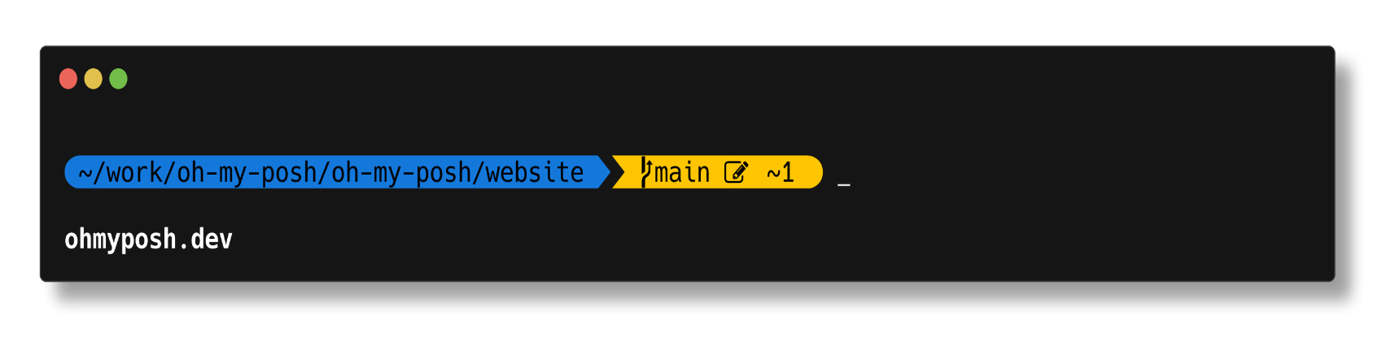](https://github.com/JanDeDobbeleer/oh-my-posh/blob/main/themes/cobalt2.omp.json)

[**craver**](https://github.com/JanDeDobbeleer/oh-my-posh/blob/main/themes/craver.omp.json)[**​**](https://ohmyposh.dev/docs/themes#craver)

[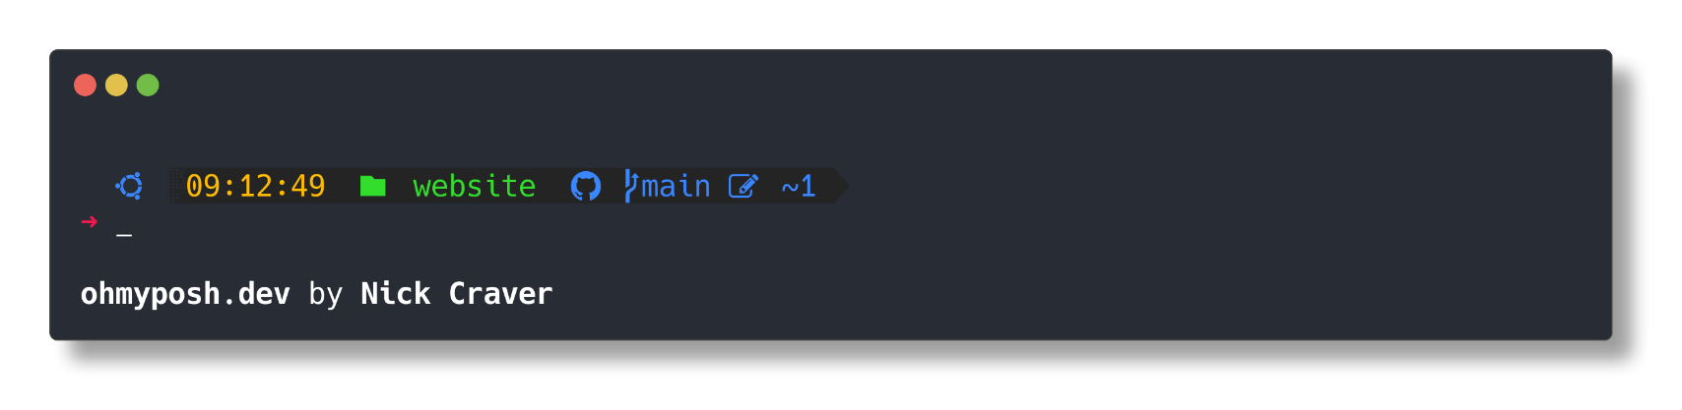](https://github.com/JanDeDobbeleer/oh-my-posh/blob/main/themes/craver.omp.json)

[**darkblood**](https://github.com/JanDeDobbeleer/oh-my-posh/blob/main/themes/darkblood.omp.json)[**​**](https://ohmyposh.dev/docs/themes#darkblood)

[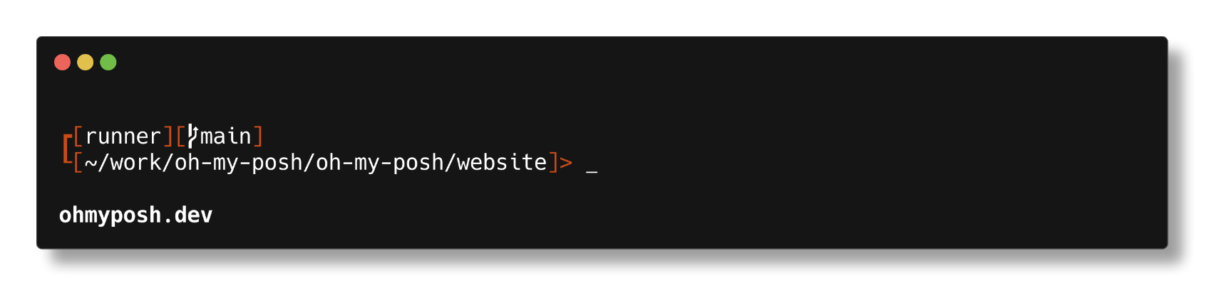](https://github.com/JanDeDobbeleer/oh-my-posh/blob/main/themes/darkblood.omp.json)

[**default**](https://github.com/JanDeDobbeleer/oh-my-posh/blob/main/themes/default.omp.json)[**​**](https://ohmyposh.dev/docs/themes#default)

[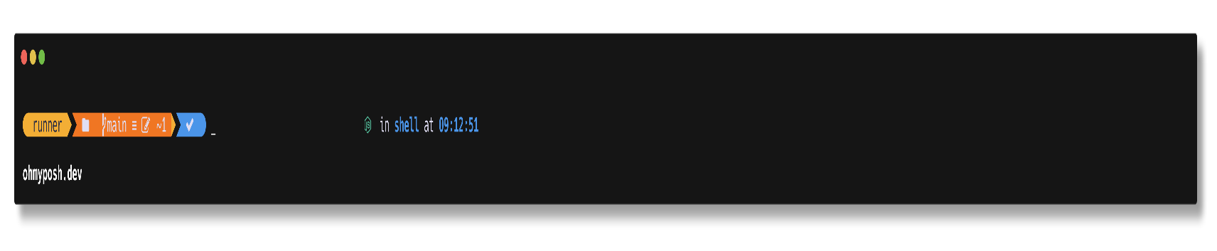](https://github.com/JanDeDobbeleer/oh-my-posh/blob/main/themes/default.omp.json)

[**devious-diamonds**](https://github.com/JanDeDobbeleer/oh-my-posh/blob/main/themes/devious-diamonds.omp.yaml)[**​**](https://ohmyposh.dev/docs/themes#devious-diamonds)

[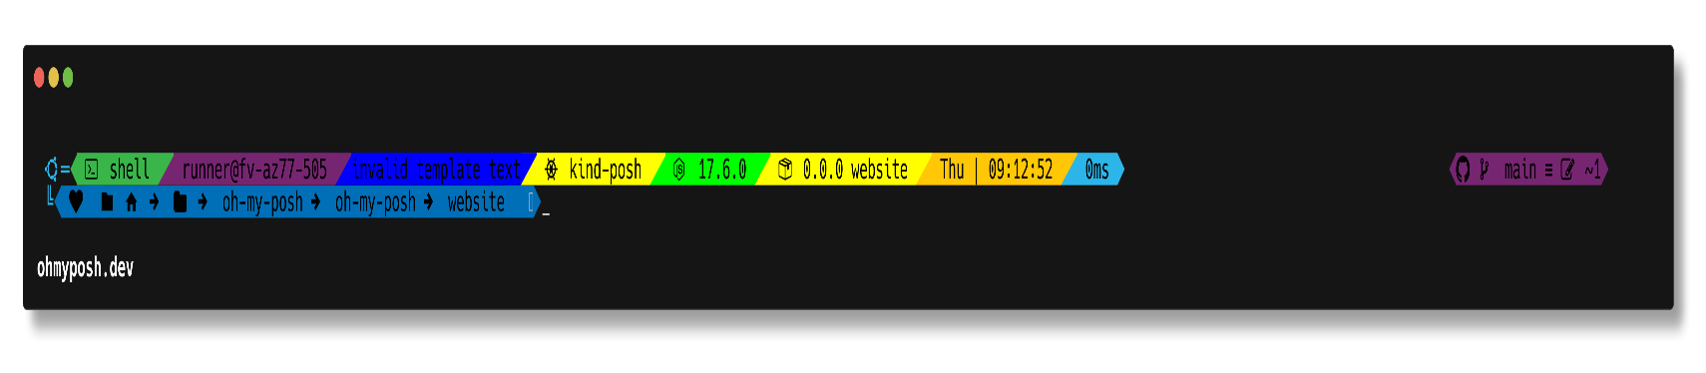](https://github.com/JanDeDobbeleer/oh-my-posh/blob/main/themes/devious-diamonds.omp.yaml)

[**di4am0nd**](https://github.com/JanDeDobbeleer/oh-my-posh/blob/main/themes/di4am0nd.omp.json)[**​**](https://ohmyposh.dev/docs/themes#di4am0nd)

[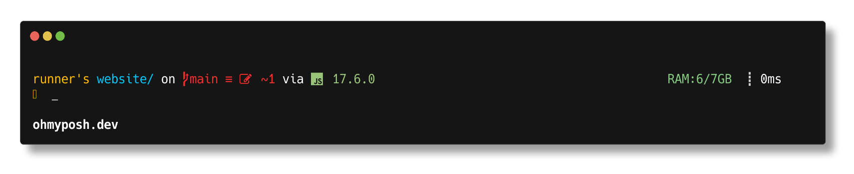](https://github.com/JanDeDobbeleer/oh-my-posh/blob/main/themes/di4am0nd.omp.json)

[**dracula**](https://github.com/JanDeDobbeleer/oh-my-posh/blob/main/themes/dracula.omp.json)[**​**](https://ohmyposh.dev/docs/themes#dracula)

[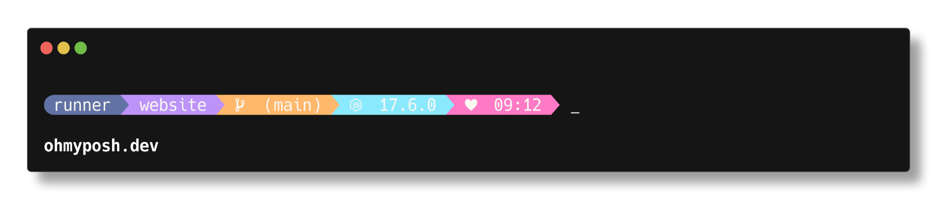](https://github.com/JanDeDobbeleer/oh-my-posh/blob/main/themes/dracula.omp.json)

[**easy-term**](https://github.com/JanDeDobbeleer/oh-my-posh/blob/main/themes/easy-term.omp.json)[**​**](https://ohmyposh.dev/docs/themes#easy-term)

[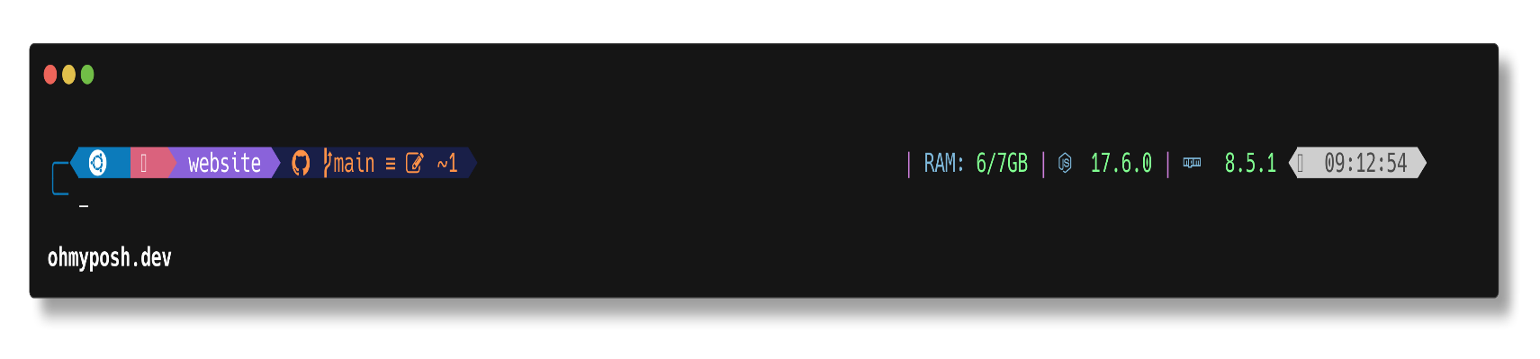](https://github.com/JanDeDobbeleer/oh-my-posh/blob/main/themes/easy-term.omp.json)

[**emodipt-extend**](https://github.com/JanDeDobbeleer/oh-my-posh/blob/main/themes/emodipt-extend.omp.json)[**​**](https://ohmyposh.dev/docs/themes#emodipt-extend)

[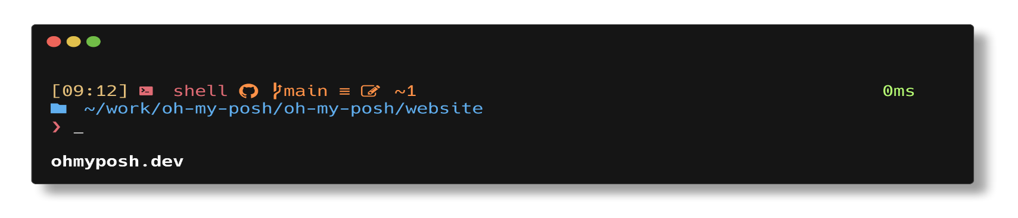](https://github.com/JanDeDobbeleer/oh-my-posh/blob/main/themes/emodipt-extend.omp.json)

[**emodipt**](https://github.com/JanDeDobbeleer/oh-my-posh/blob/main/themes/emodipt.omp.json)[**​**](https://ohmyposh.dev/docs/themes#emodipt)

[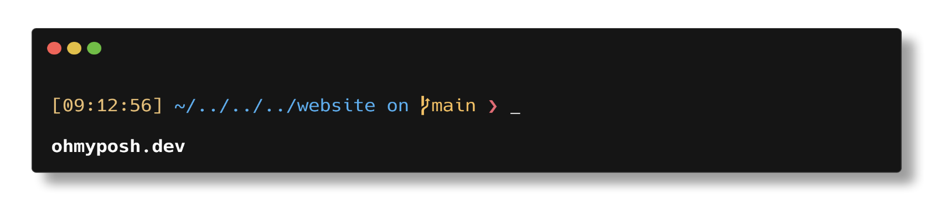](https://github.com/JanDeDobbeleer/oh-my-posh/blob/main/themes/emodipt.omp.json)

[**fish**](https://github.com/JanDeDobbeleer/oh-my-posh/blob/main/themes/fish.omp.json)[**​**](https://ohmyposh.dev/docs/themes#fish)

[](https://github.com/JanDeDobbeleer/oh-my-posh/blob/main/themes/fish.omp.json)

[**free-ukraine**](https://github.com/JanDeDobbeleer/oh-my-posh/blob/main/themes/free-ukraine.omp.json)[**​**](https://ohmyposh.dev/docs/themes#free-ukraine)

[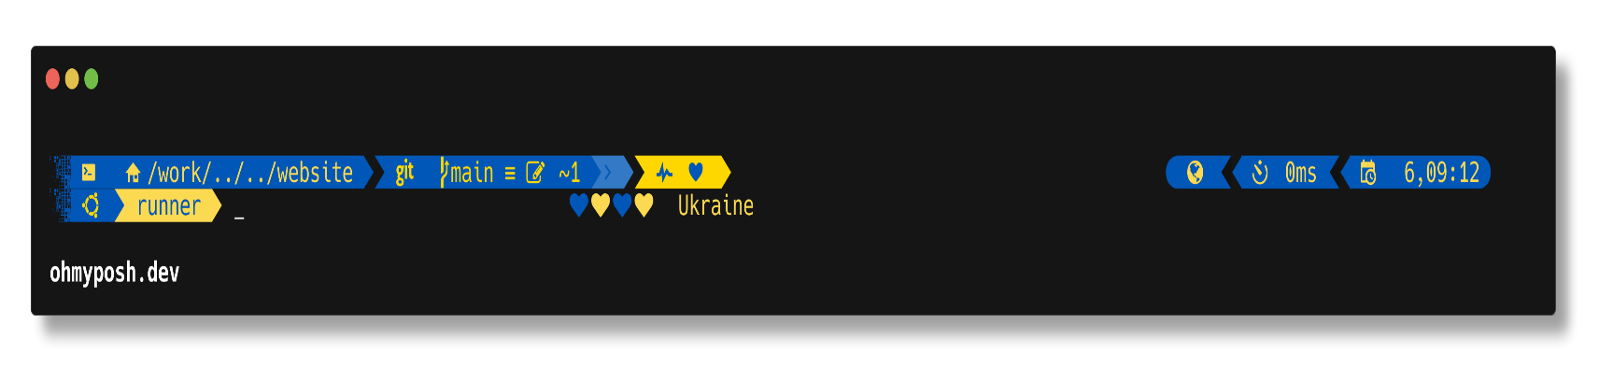](https://github.com/JanDeDobbeleer/oh-my-posh/blob/main/themes/free-ukraine.omp.json)

[**froczh**](https://github.com/JanDeDobbeleer/oh-my-posh/blob/main/themes/froczh.omp.json)[**​**](https://ohmyposh.dev/docs/themes#froczh)

[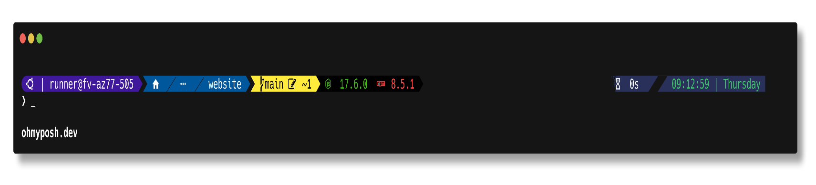](https://github.com/JanDeDobbeleer/oh-my-posh/blob/main/themes/froczh.omp.json)

[**glowsticks**](https://github.com/JanDeDobbeleer/oh-my-posh/blob/main/themes/glowsticks.omp.yaml)[**​**](https://ohmyposh.dev/docs/themes#glowsticks)

[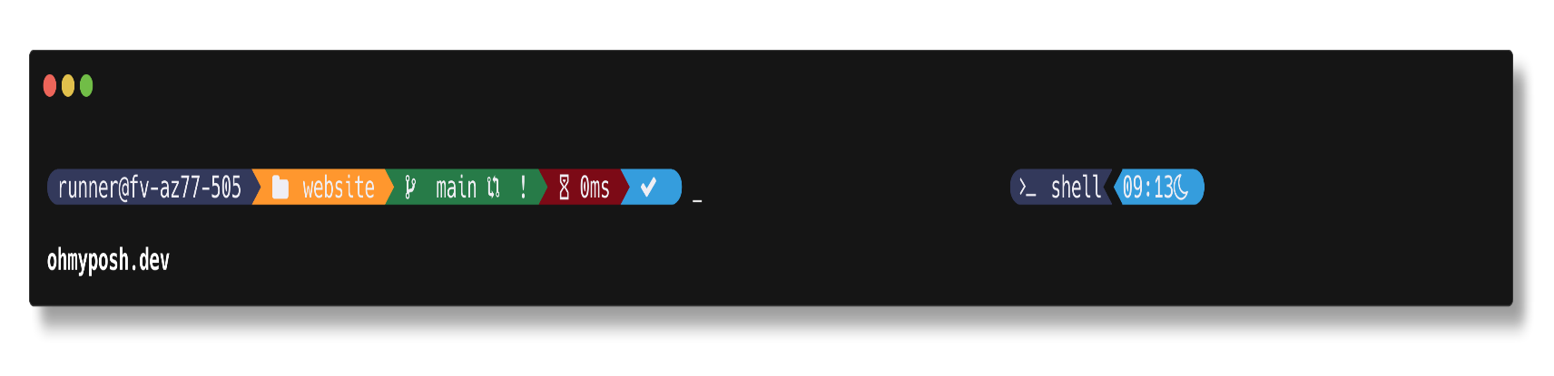](https://github.com/JanDeDobbeleer/oh-my-posh/blob/main/themes/glowsticks.omp.yaml)

[**gmay**](https://github.com/JanDeDobbeleer/oh-my-posh/blob/main/themes/gmay.omp.json)[**​**](https://ohmyposh.dev/docs/themes#gmay)

[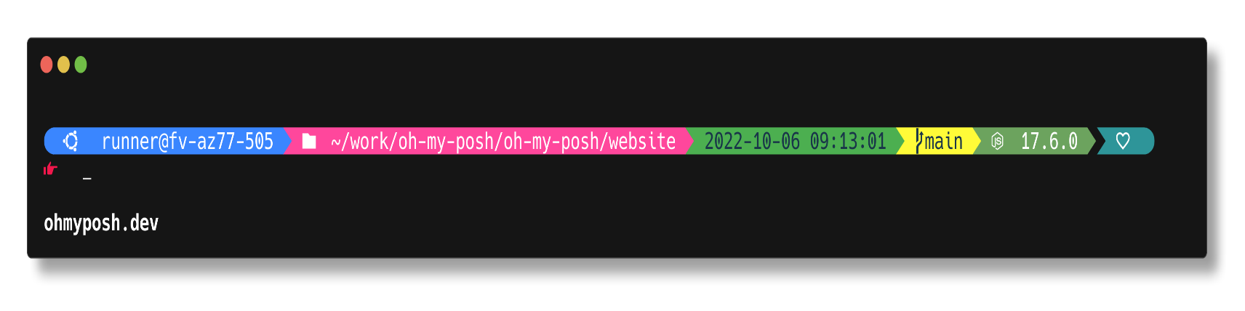](https://github.com/JanDeDobbeleer/oh-my-posh/blob/main/themes/gmay.omp.json)

[**grandpa-style**](https://github.com/JanDeDobbeleer/oh-my-posh/blob/main/themes/grandpa-style.omp.json)[**​**](https://ohmyposh.dev/docs/themes#grandpa-style)

[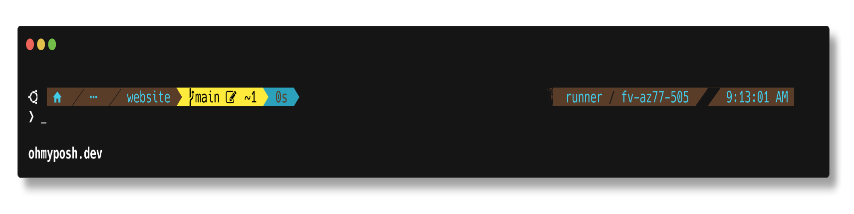](https://github.com/JanDeDobbeleer/oh-my-posh/blob/main/themes/grandpa-style.omp.json)

[**gruvbox**](https://github.com/JanDeDobbeleer/oh-my-posh/blob/main/themes/gruvbox.omp.json)[**​**](https://ohmyposh.dev/docs/themes#gruvbox)

[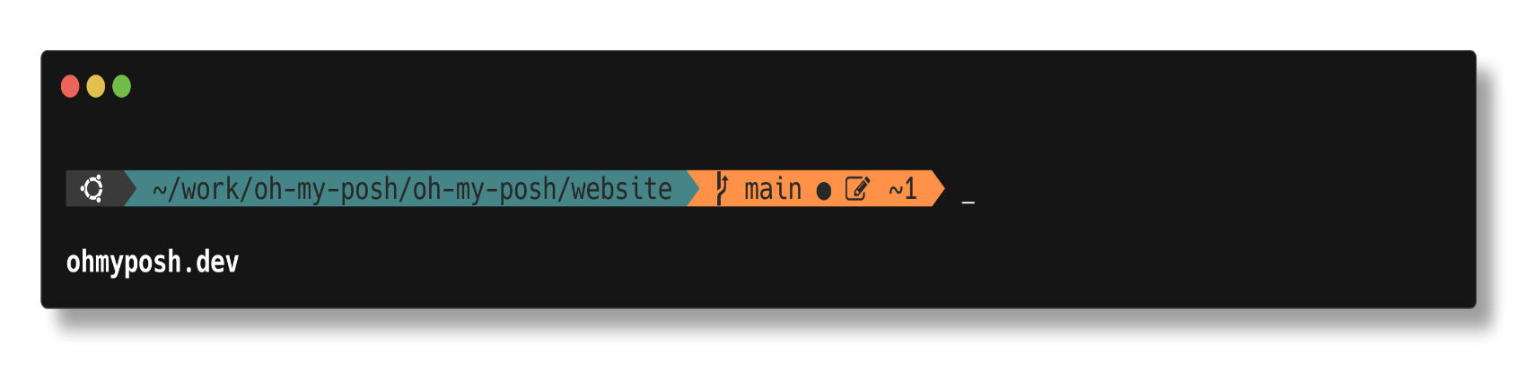](https://github.com/JanDeDobbeleer/oh-my-posh/blob/main/themes/gruvbox.omp.json)

[**half-life**](https://github.com/JanDeDobbeleer/oh-my-posh/blob/main/themes/half-life.omp.json)[**​**](https://ohmyposh.dev/docs/themes#half-life)

[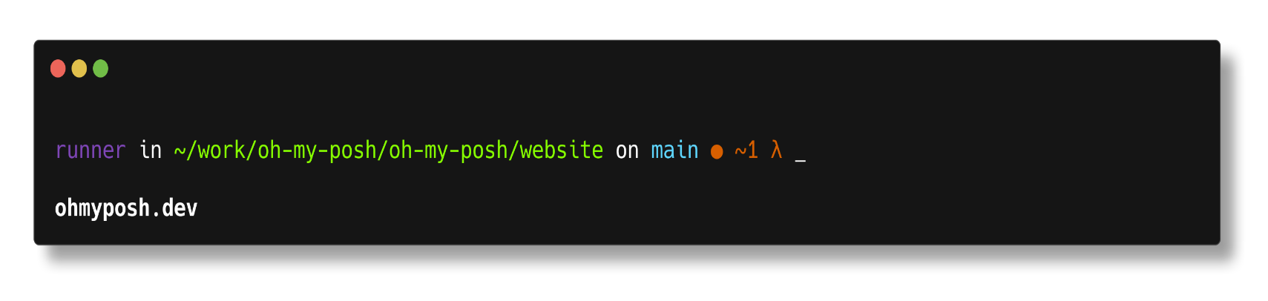](https://github.com/JanDeDobbeleer/oh-my-posh/blob/main/themes/half-life.omp.json)

[**honukai**](https://github.com/JanDeDobbeleer/oh-my-posh/blob/main/themes/honukai.omp.json)[**​**](https://ohmyposh.dev/docs/themes#honukai)

[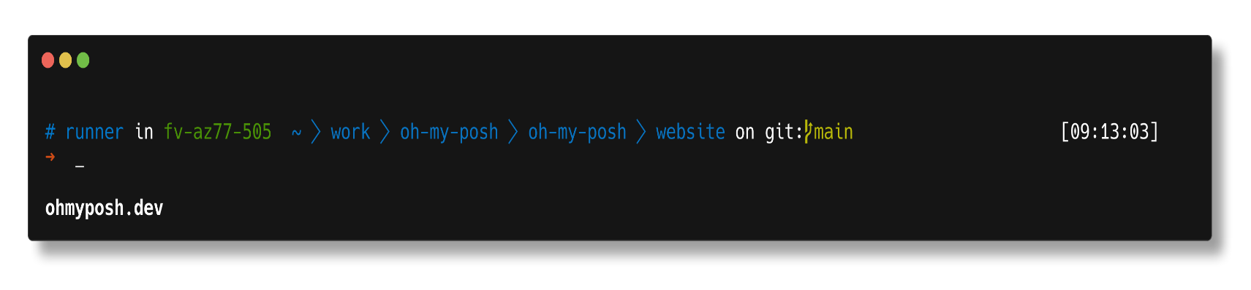](https://github.com/JanDeDobbeleer/oh-my-posh/blob/main/themes/honukai.omp.json)

[**hotstick.minimal**](https://github.com/JanDeDobbeleer/oh-my-posh/blob/main/themes/hotstick.minimal.omp.json)[**​**](https://ohmyposh.dev/docs/themes#hotstickminimal)

[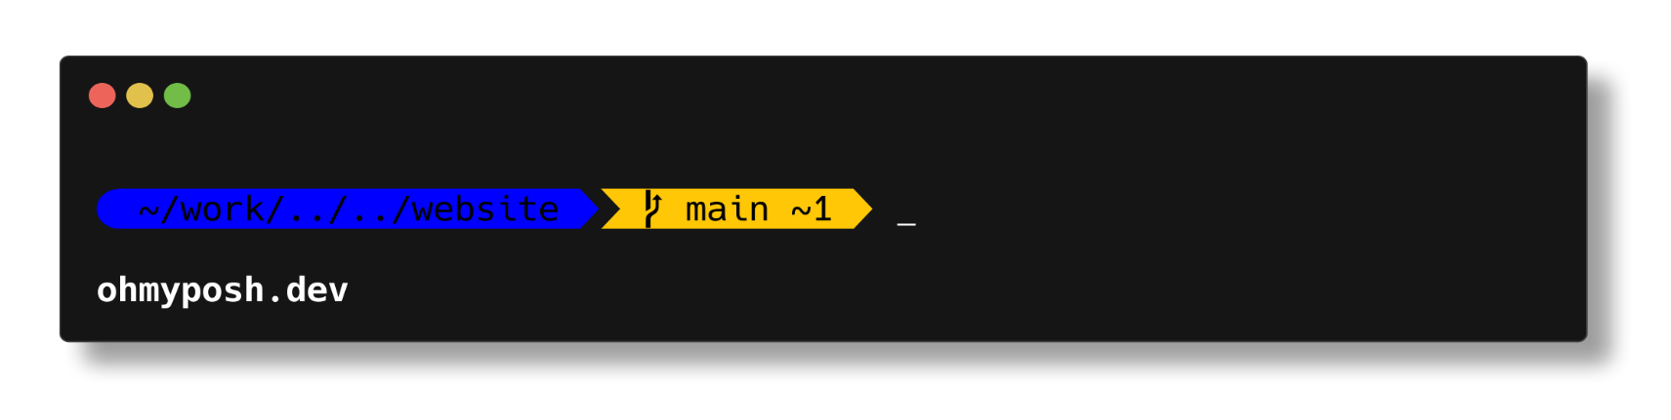](https://github.com/JanDeDobbeleer/oh-my-posh/blob/main/themes/hotstick.minimal.omp.json)

[**hul10**](https://github.com/JanDeDobbeleer/oh-my-posh/blob/main/themes/hul10.omp.json)[**​**](https://ohmyposh.dev/docs/themes#hul10)

[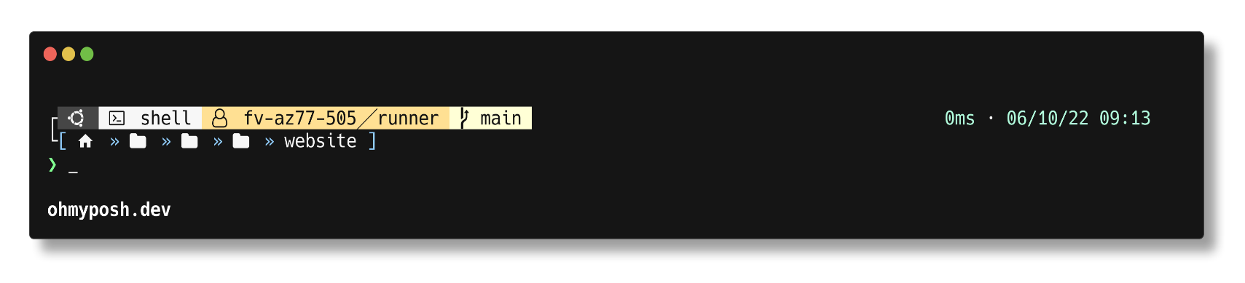](https://github.com/JanDeDobbeleer/oh-my-posh/blob/main/themes/hul10.omp.json)

[**hunk**](https://github.com/JanDeDobbeleer/oh-my-posh/blob/main/themes/hunk.omp.json)[**​**](https://ohmyposh.dev/docs/themes#hunk)

[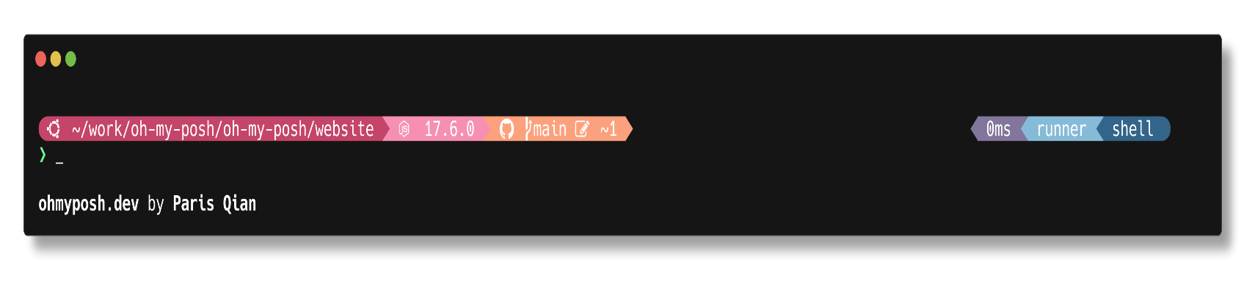](https://github.com/JanDeDobbeleer/oh-my-posh/blob/main/themes/hunk.omp.json)

[**huvix**](https://github.com/JanDeDobbeleer/oh-my-posh/blob/main/themes/huvix.omp.json)[**​**](https://ohmyposh.dev/docs/themes#huvix)

[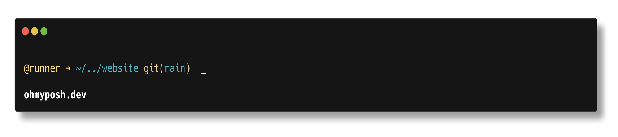](https://github.com/JanDeDobbeleer/oh-my-posh/blob/main/themes/huvix.omp.json)

[**if\_tea**](https://github.com/JanDeDobbeleer/oh-my-posh/blob/main/themes/if_tea.omp.json)[**​**](https://ohmyposh.dev/docs/themes#if_tea)

[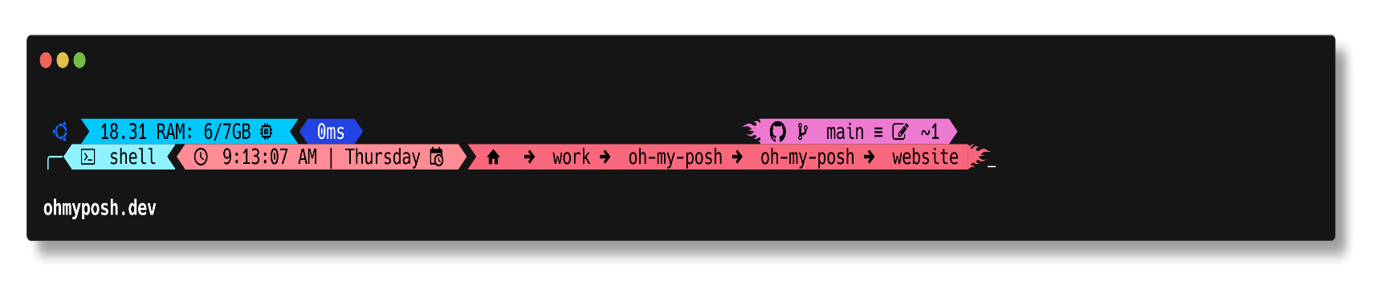](https://github.com/JanDeDobbeleer/oh-my-posh/blob/main/themes/if_tea.omp.json)

[**illusi0n**](https://github.com/JanDeDobbeleer/oh-my-posh/blob/main/themes/illusi0n.omp.json)[**​**](https://ohmyposh.dev/docs/themes#illusi0n)

[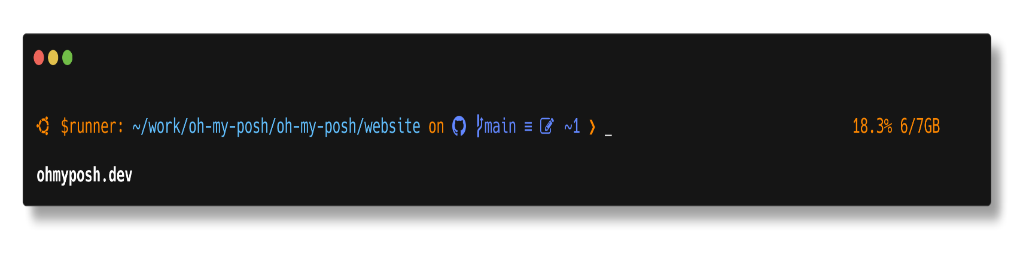](https://github.com/JanDeDobbeleer/oh-my-posh/blob/main/themes/illusi0n.omp.json)

[**iterm2**](https://github.com/JanDeDobbeleer/oh-my-posh/blob/main/themes/iterm2.omp.json)[**​**](https://ohmyposh.dev/docs/themes#iterm2)

[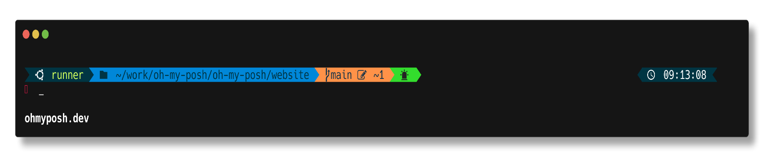](https://github.com/JanDeDobbeleer/oh-my-posh/blob/main/themes/iterm2.omp.json)

[**jandedobbeleer**](https://github.com/JanDeDobbeleer/oh-my-posh/blob/main/themes/jandedobbeleer.omp.json)[**​**](https://ohmyposh.dev/docs/themes#jandedobbeleer)

[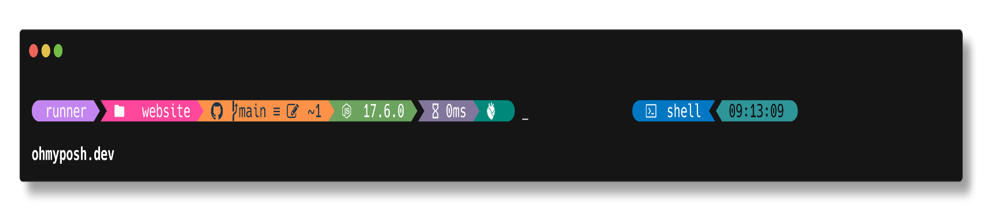](https://github.com/JanDeDobbeleer/oh-my-posh/blob/main/themes/jandedobbeleer.omp.json)

[**jblab\_2021**](https://github.com/JanDeDobbeleer/oh-my-posh/blob/main/themes/jblab_2021.omp.json)[**​**](https://ohmyposh.dev/docs/themes#jblab_2021)

[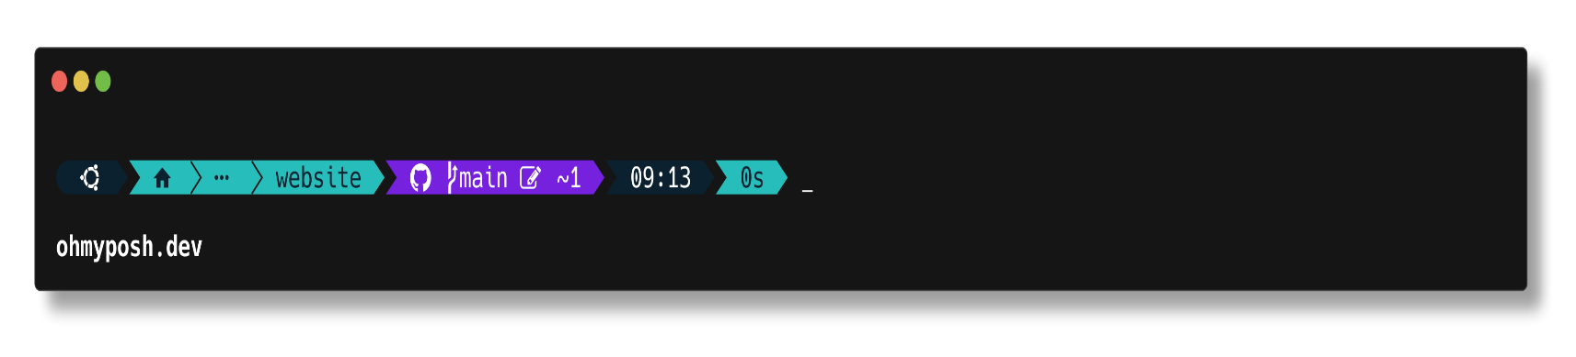](https://github.com/JanDeDobbeleer/oh-my-posh/blob/main/themes/jblab_2021.omp.json)

[**jonnychipz**](https://github.com/JanDeDobbeleer/oh-my-posh/blob/main/themes/jonnychipz.omp.json)[**​**](https://ohmyposh.dev/docs/themes#jonnychipz)

[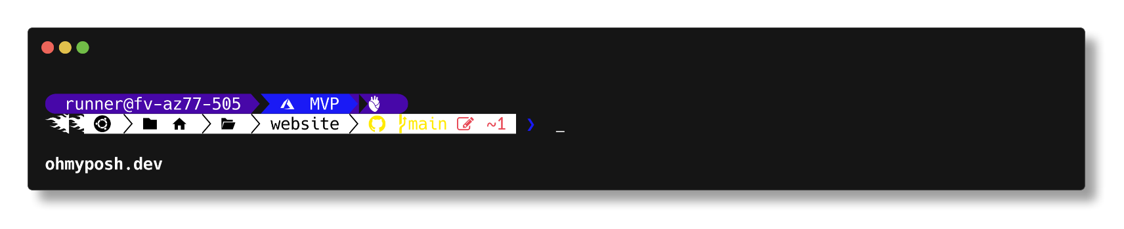](https://github.com/JanDeDobbeleer/oh-my-posh/blob/main/themes/jonnychipz.omp.json)

[**json**](https://github.com/JanDeDobbeleer/oh-my-posh/blob/main/themes/json.omp.json)[**​**](https://ohmyposh.dev/docs/themes#json)

[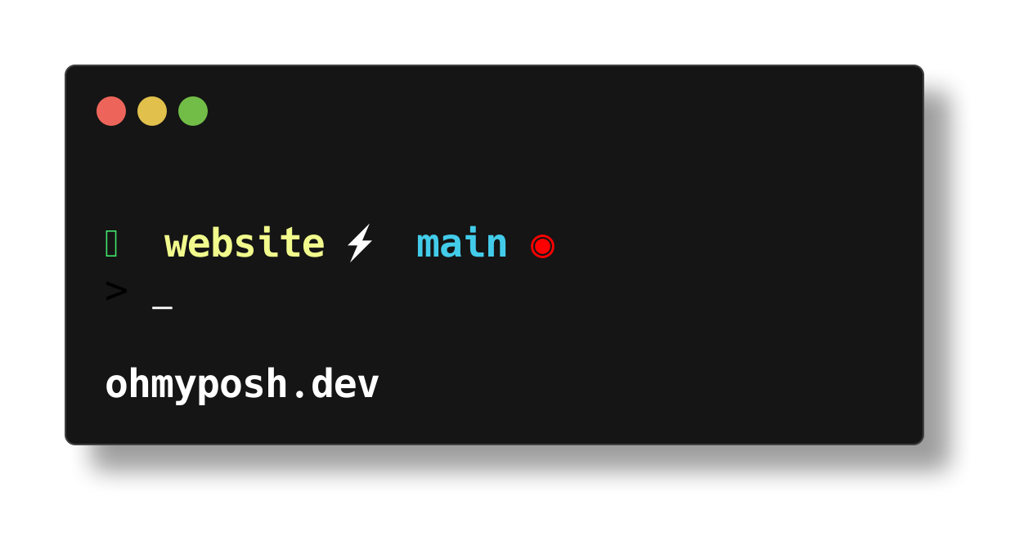](https://github.com/JanDeDobbeleer/oh-my-posh/blob/main/themes/json.omp.json)

[**jtracey93**](https://github.com/JanDeDobbeleer/oh-my-posh/blob/main/themes/jtracey93.omp.json)[**​**](https://ohmyposh.dev/docs/themes#jtracey93)

[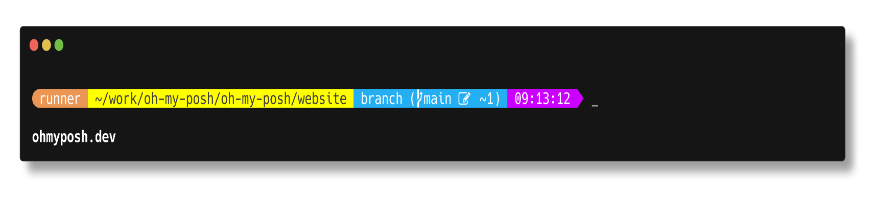](https://github.com/JanDeDobbeleer/oh-my-posh/blob/main/themes/jtracey93.omp.json)

[**jv\_sitecorian**](https://github.com/JanDeDobbeleer/oh-my-posh/blob/main/themes/jv_sitecorian.omp.json)[**​**](https://ohmyposh.dev/docs/themes#jv_sitecorian)

[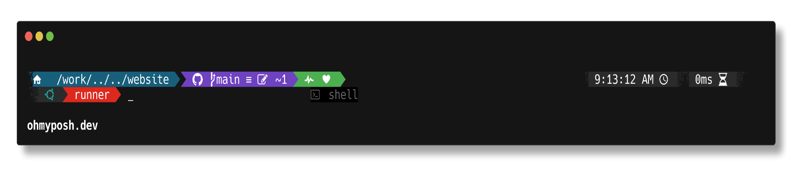](https://github.com/JanDeDobbeleer/oh-my-posh/blob/main/themes/jv_sitecorian.omp.json)

[**kali**](https://github.com/JanDeDobbeleer/oh-my-posh/blob/main/themes/kali.omp.json)[**​**](https://ohmyposh.dev/docs/themes#kali)

[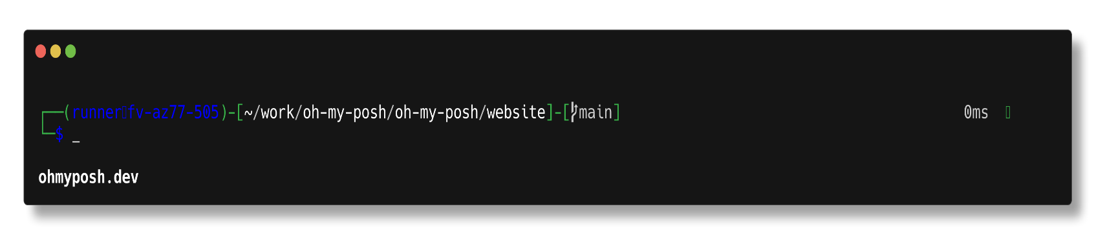](https://github.com/JanDeDobbeleer/oh-my-posh/blob/main/themes/kali.omp.json)

[**kushal**](https://github.com/JanDeDobbeleer/oh-my-posh/blob/main/themes/kushal.omp.json)[**​**](https://ohmyposh.dev/docs/themes#kushal)

[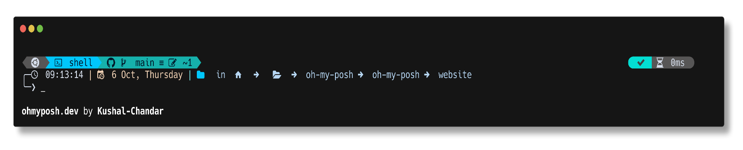](https://github.com/JanDeDobbeleer/oh-my-posh/blob/main/themes/kushal.omp.json)

[**lambda**](https://github.com/JanDeDobbeleer/oh-my-posh/blob/main/themes/lambda.omp.json)[**​**](https://ohmyposh.dev/docs/themes#lambda)

[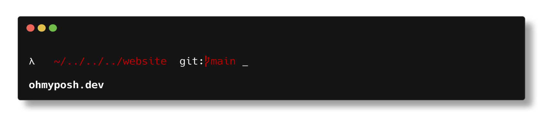](https://github.com/JanDeDobbeleer/oh-my-posh/blob/main/themes/lambda.omp.json)

[**lambdageneration**](https://github.com/JanDeDobbeleer/oh-my-posh/blob/main/themes/lambdageneration.omp.json)[**​**](https://ohmyposh.dev/docs/themes#lambdageneration)

[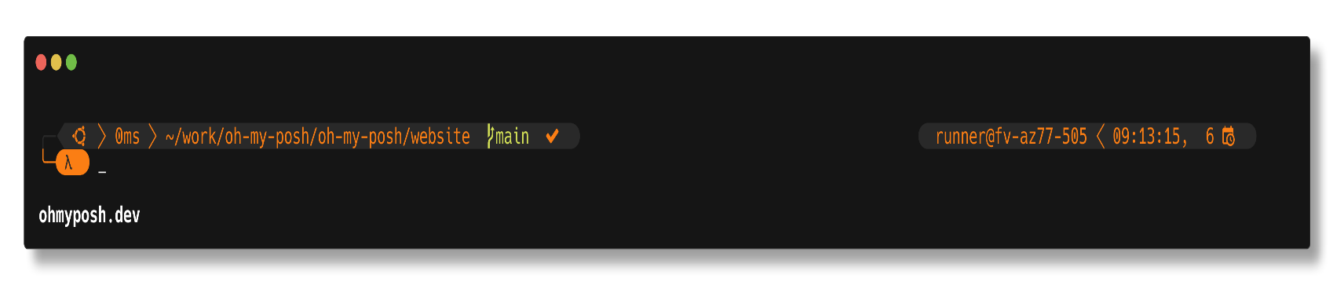](https://github.com/JanDeDobbeleer/oh-my-posh/blob/main/themes/lambdageneration.omp.json)

[**larserikfinholt**](https://github.com/JanDeDobbeleer/oh-my-posh/blob/main/themes/larserikfinholt.omp.json)[**​**](https://ohmyposh.dev/docs/themes#larserikfinholt)

[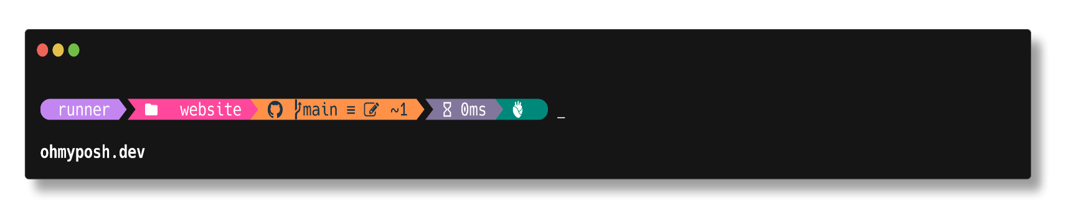](https://github.com/JanDeDobbeleer/oh-my-posh/blob/main/themes/larserikfinholt.omp.json)

[**lightgreen**](https://github.com/JanDeDobbeleer/oh-my-posh/blob/main/themes/lightgreen.omp.json)[**​**](https://ohmyposh.dev/docs/themes#lightgreen)

[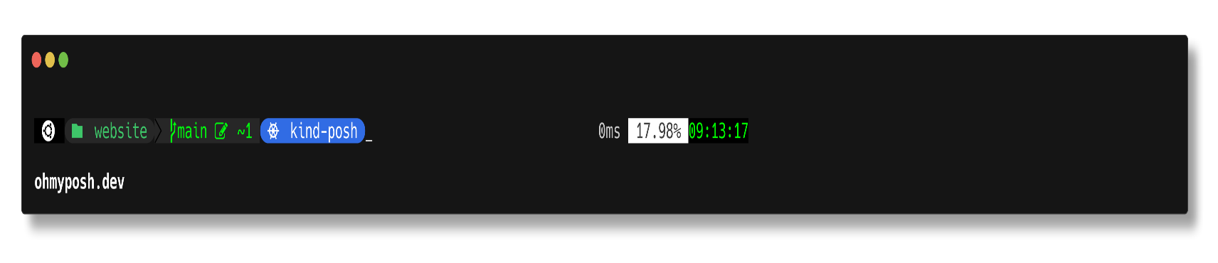](https://github.com/JanDeDobbeleer/oh-my-posh/blob/main/themes/lightgreen.omp.json)

[**marcduiker**](https://github.com/JanDeDobbeleer/oh-my-posh/blob/main/themes/marcduiker.omp.json)[**​**](https://ohmyposh.dev/docs/themes#marcduiker)

[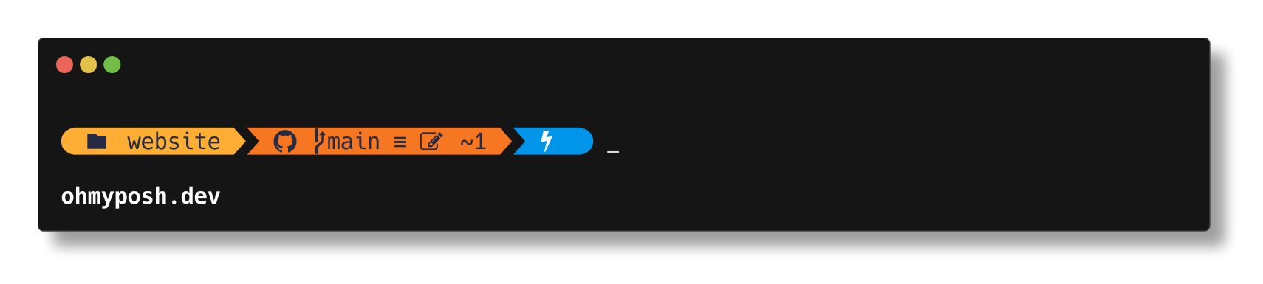](https://github.com/JanDeDobbeleer/oh-my-posh/blob/main/themes/marcduiker.omp.json)

[**markbull**](https://github.com/JanDeDobbeleer/oh-my-posh/blob/main/themes/markbull.omp.json)[**​**](https://ohmyposh.dev/docs/themes#markbull)

[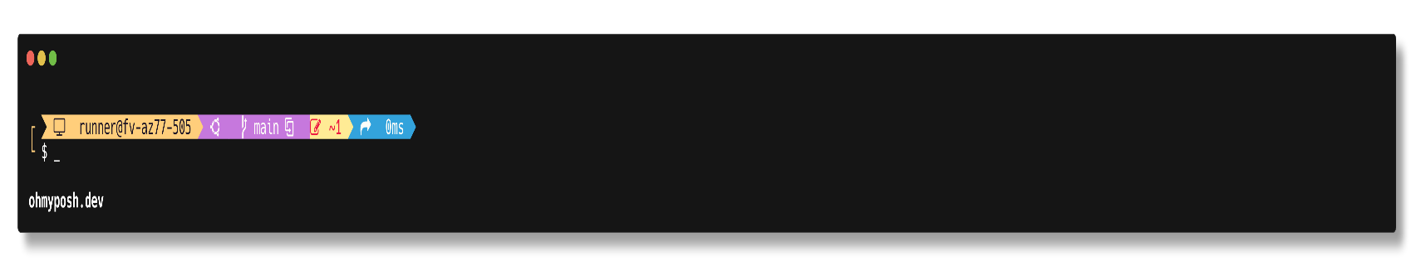](https://github.com/JanDeDobbeleer/oh-my-posh/blob/main/themes/markbull.omp.json)

[**material**](https://github.com/JanDeDobbeleer/oh-my-posh/blob/main/themes/material.omp.json)[**​**](https://ohmyposh.dev/docs/themes#material)

[](https://github.com/JanDeDobbeleer/oh-my-posh/blob/main/themes/material.omp.json)

[**microverse-power**](https://github.com/JanDeDobbeleer/oh-my-posh/blob/main/themes/microverse-power.omp.json)[**​**](https://ohmyposh.dev/docs/themes#microverse-power)

[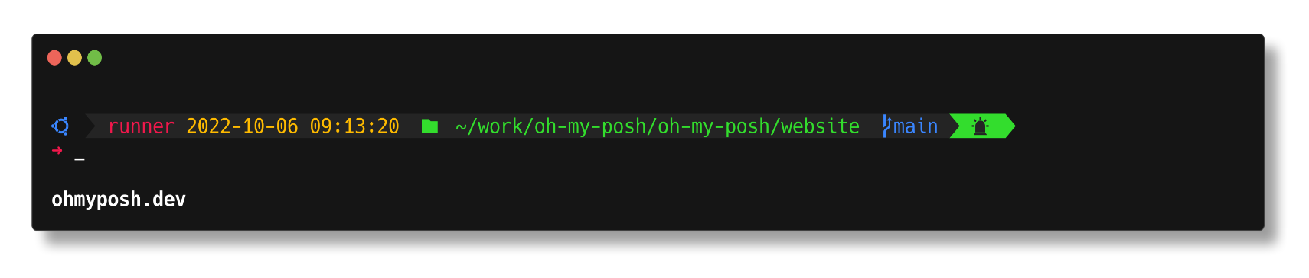](https://github.com/JanDeDobbeleer/oh-my-posh/blob/main/themes/microverse-power.omp.json)

[**mojada**](https://github.com/JanDeDobbeleer/oh-my-posh/blob/main/themes/mojada.omp.json)[**​**](https://ohmyposh.dev/docs/themes#mojada)

[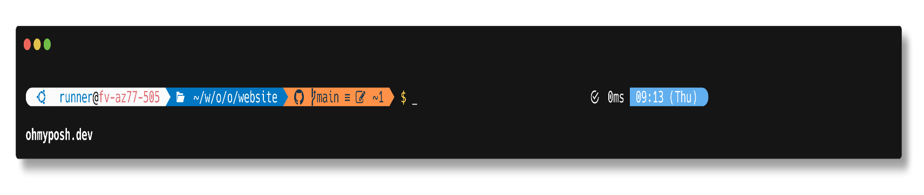](https://github.com/JanDeDobbeleer/oh-my-posh/blob/main/themes/mojada.omp.json)

[**montys**](https://github.com/JanDeDobbeleer/oh-my-posh/blob/main/themes/montys.omp.json)[**​**](https://ohmyposh.dev/docs/themes#montys)

[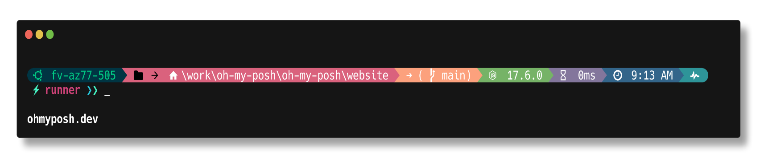](https://github.com/JanDeDobbeleer/oh-my-posh/blob/main/themes/montys.omp.json)

[**mt**](https://github.com/JanDeDobbeleer/oh-my-posh/blob/main/themes/mt.omp.json)[**​**](https://ohmyposh.dev/docs/themes#mt)

[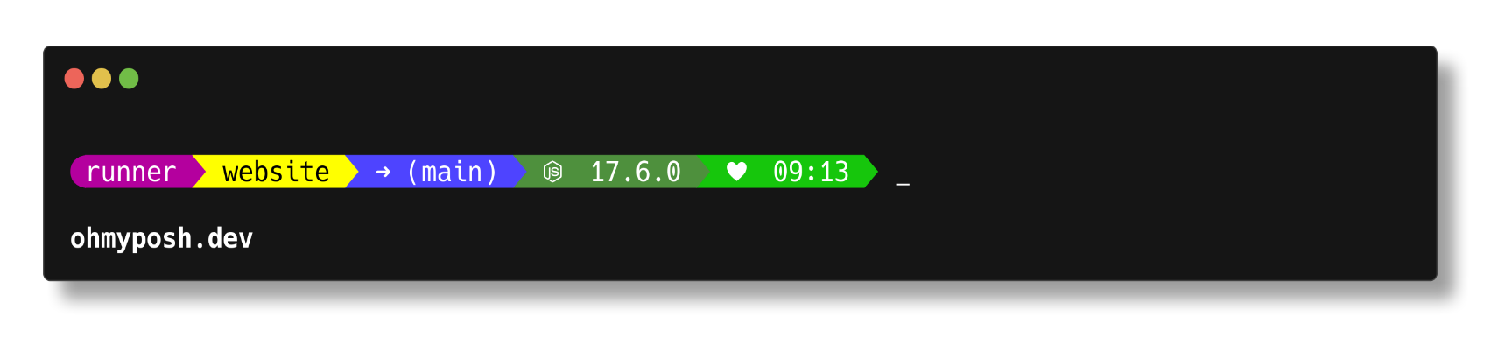](https://github.com/JanDeDobbeleer/oh-my-posh/blob/main/themes/mt.omp.json)

[**multiverse-neon**](https://github.com/JanDeDobbeleer/oh-my-posh/blob/main/themes/multiverse-neon.omp.json)[**​**](https://ohmyposh.dev/docs/themes#multiverse-neon)

[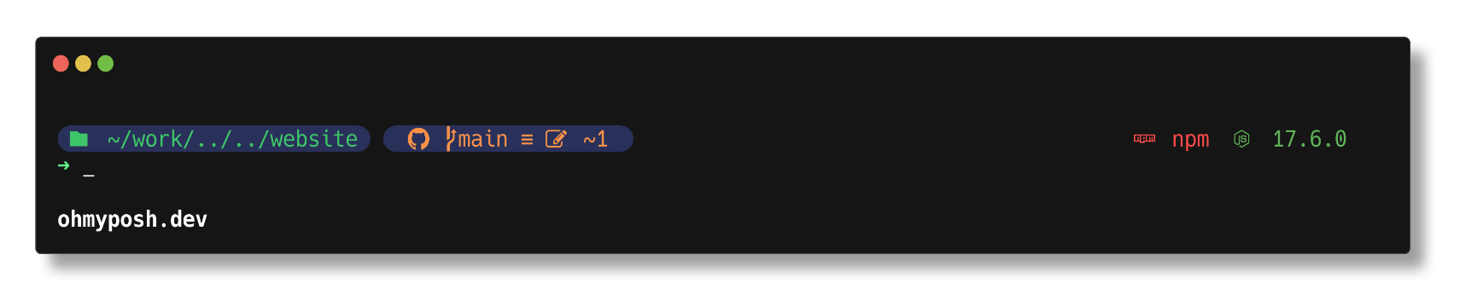](https://github.com/JanDeDobbeleer/oh-my-posh/blob/main/themes/multiverse-neon.omp.json)

[**negligible**](https://github.com/JanDeDobbeleer/oh-my-posh/blob/main/themes/negligible.omp.json)[**​**](https://ohmyposh.dev/docs/themes#negligible)

[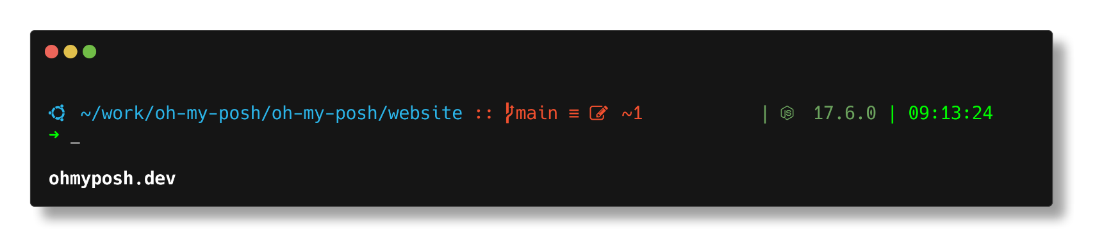](https://github.com/JanDeDobbeleer/oh-my-posh/blob/main/themes/negligible.omp.json)

[**neko**](https://github.com/JanDeDobbeleer/oh-my-posh/blob/main/themes/neko.omp.json)[**​**](https://ohmyposh.dev/docs/themes#neko)

[](https://github.com/JanDeDobbeleer/oh-my-posh/blob/main/themes/neko.omp.json)

[**night-owl**](https://github.com/JanDeDobbeleer/oh-my-posh/blob/main/themes/night-owl.omp.json)[**​**](https://ohmyposh.dev/docs/themes#night-owl)

[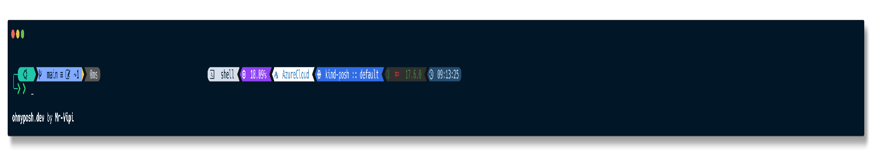](https://github.com/JanDeDobbeleer/oh-my-posh/blob/main/themes/night-owl.omp.json)

[**nordtron**](https://github.com/JanDeDobbeleer/oh-my-posh/blob/main/themes/nordtron.omp.json)[**​**](https://ohmyposh.dev/docs/themes#nordtron)

[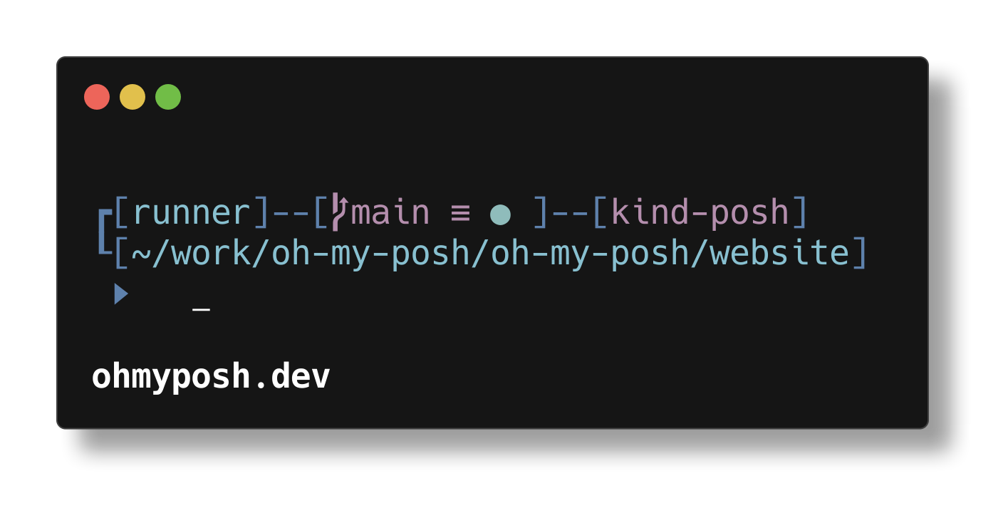](https://github.com/JanDeDobbeleer/oh-my-posh/blob/main/themes/nordtron.omp.json)

[**nu4a**](https://github.com/JanDeDobbeleer/oh-my-posh/blob/main/themes/nu4a.omp.json)[**​**](https://ohmyposh.dev/docs/themes#nu4a)

[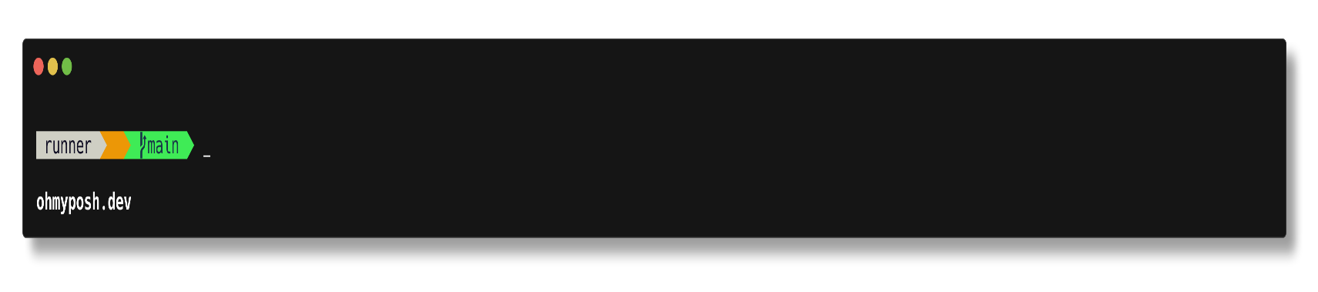](https://github.com/JanDeDobbeleer/oh-my-posh/blob/main/themes/nu4a.omp.json)

[**onehalf.minimal**](https://github.com/JanDeDobbeleer/oh-my-posh/blob/main/themes/onehalf.minimal.omp.json)[**​**](https://ohmyposh.dev/docs/themes#onehalfminimal)

[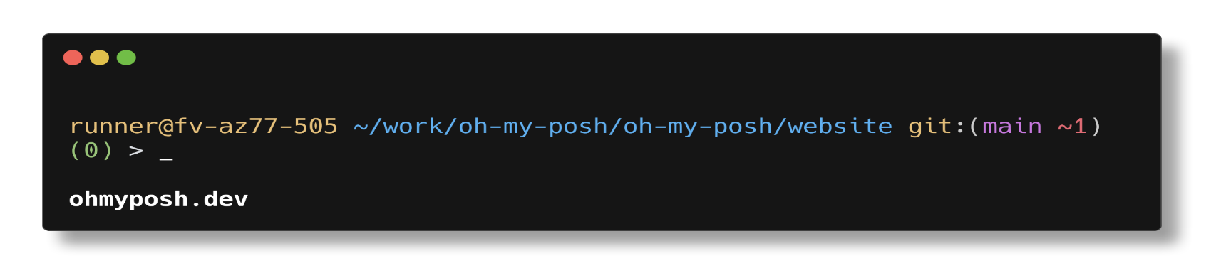](https://github.com/JanDeDobbeleer/oh-my-posh/blob/main/themes/onehalf.minimal.omp.json)

[**paradox**](https://github.com/JanDeDobbeleer/oh-my-posh/blob/main/themes/paradox.omp.json)[**​**](https://ohmyposh.dev/docs/themes#paradox)

[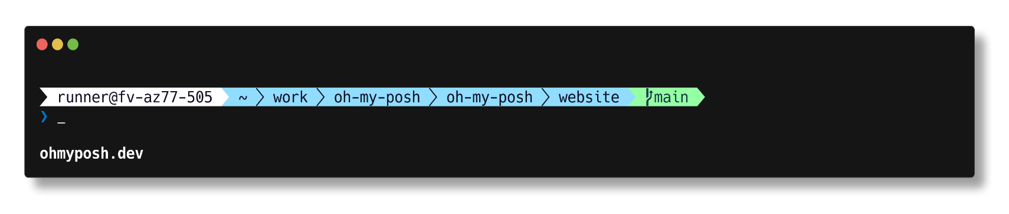](https://github.com/JanDeDobbeleer/oh-my-posh/blob/main/themes/paradox.omp.json)

[**pararussel**](https://github.com/JanDeDobbeleer/oh-my-posh/blob/main/themes/pararussel.omp.json)[**​**](https://ohmyposh.dev/docs/themes#pararussel)

[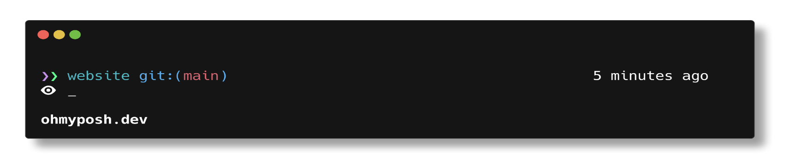](https://github.com/JanDeDobbeleer/oh-my-posh/blob/main/themes/pararussel.omp.json)

[**patriksvensson**](https://github.com/JanDeDobbeleer/oh-my-posh/blob/main/themes/patriksvensson.omp.json)[**​**](https://ohmyposh.dev/docs/themes#patriksvensson)

[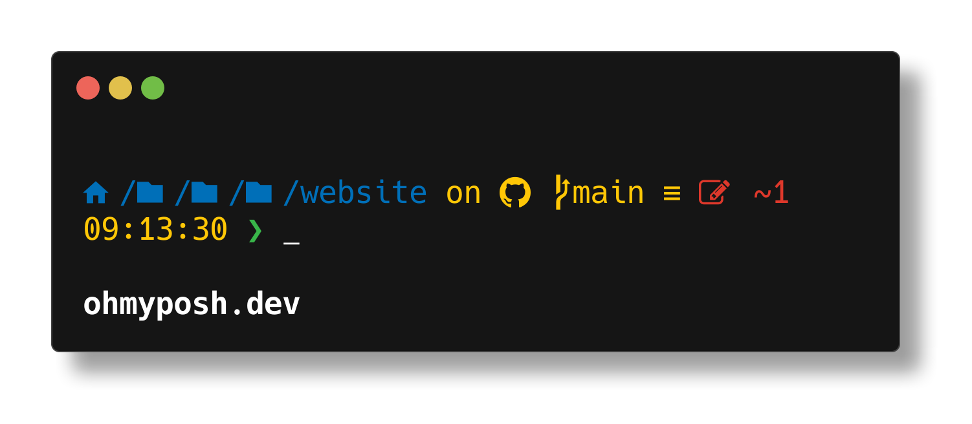](https://github.com/JanDeDobbeleer/oh-my-posh/blob/main/themes/patriksvensson.omp.json)

[**peru**](https://github.com/JanDeDobbeleer/oh-my-posh/blob/main/themes/peru.omp.json)[**​**](https://ohmyposh.dev/docs/themes#peru)

[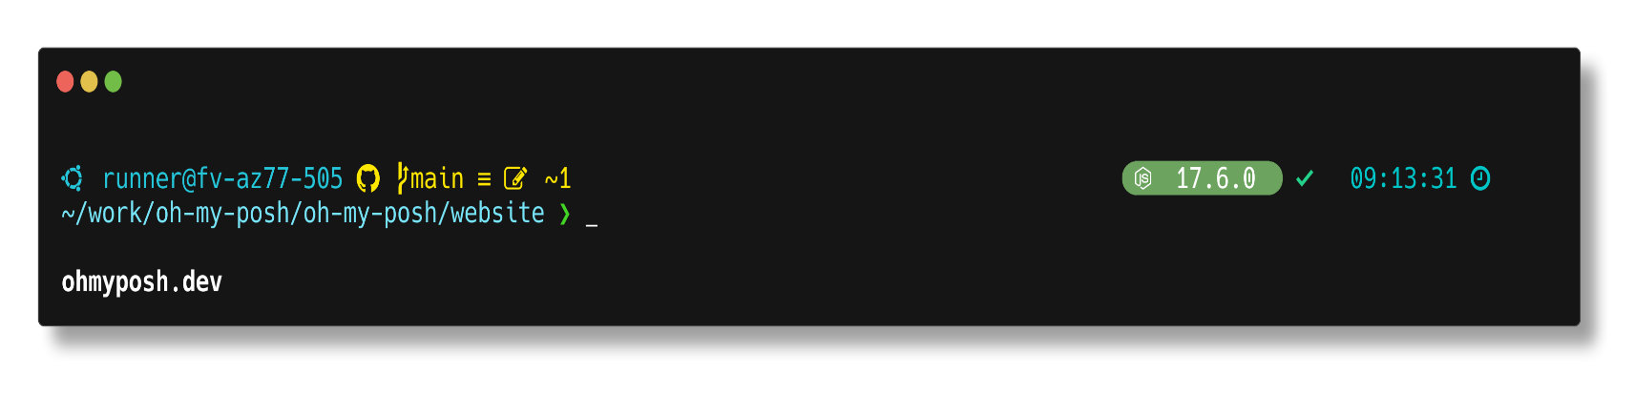](https://github.com/JanDeDobbeleer/oh-my-posh/blob/main/themes/peru.omp.json)

[**pixelrobots**](https://github.com/JanDeDobbeleer/oh-my-posh/blob/main/themes/pixelrobots.omp.json)[**​**](https://ohmyposh.dev/docs/themes#pixelrobots)

[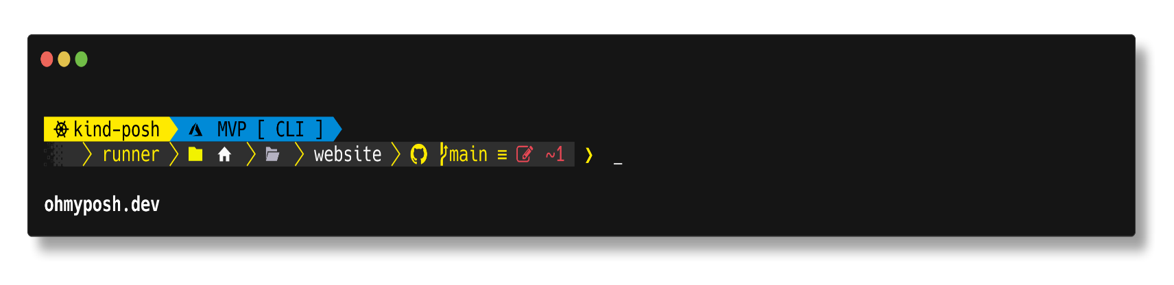](https://github.com/JanDeDobbeleer/oh-my-posh/blob/main/themes/pixelrobots.omp.json)

[**plague**](https://github.com/JanDeDobbeleer/oh-my-posh/blob/main/themes/plague.omp.json)[**​**](https://ohmyposh.dev/docs/themes#plague)

[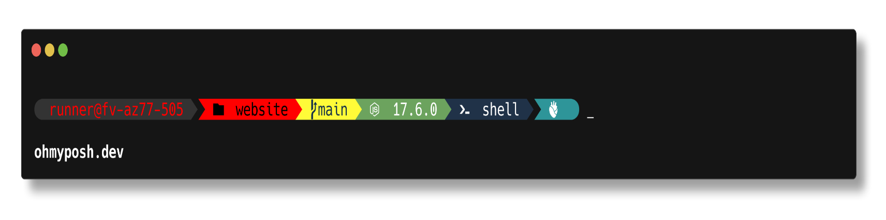](https://github.com/JanDeDobbeleer/oh-my-posh/blob/main/themes/plague.omp.json)

[**poshmon**](https://github.com/JanDeDobbeleer/oh-my-posh/blob/main/themes/poshmon.omp.json)[**​**](https://ohmyposh.dev/docs/themes#poshmon)

[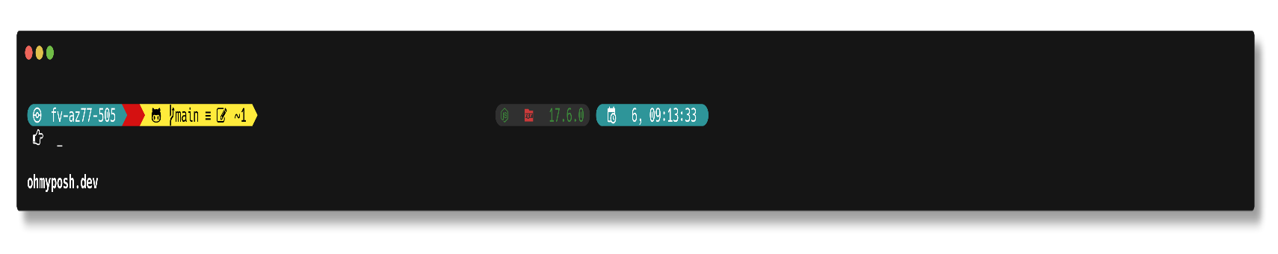](https://github.com/JanDeDobbeleer/oh-my-posh/blob/main/themes/poshmon.omp.json)

[**powerlevel10k\_classic**](https://github.com/JanDeDobbeleer/oh-my-posh/blob/main/themes/powerlevel10k_classic.omp.json)[**​**](https://ohmyposh.dev/docs/themes#powerlevel10k_classic)

[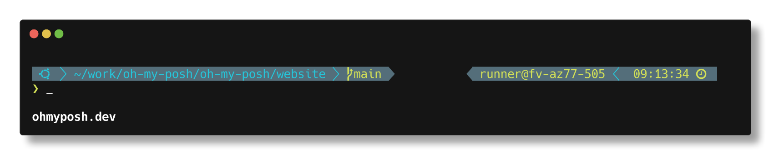](https://github.com/JanDeDobbeleer/oh-my-posh/blob/main/themes/powerlevel10k_classic.omp.json)

[**powerlevel10k\_lean**](https://github.com/JanDeDobbeleer/oh-my-posh/blob/main/themes/powerlevel10k_lean.omp.json)[**​**](https://ohmyposh.dev/docs/themes#powerlevel10k_lean)

[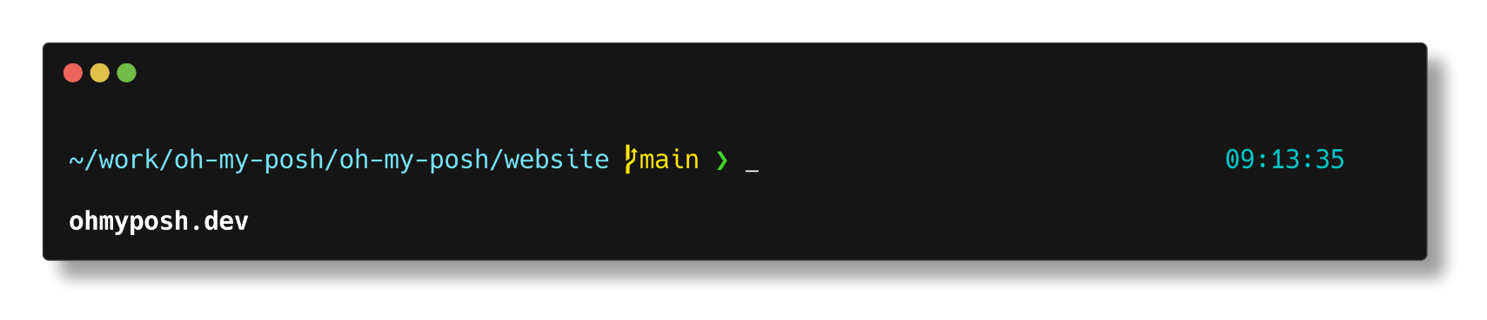](https://github.com/JanDeDobbeleer/oh-my-posh/blob/main/themes/powerlevel10k_lean.omp.json)

[**powerlevel10k\_modern**](https://github.com/JanDeDobbeleer/oh-my-posh/blob/main/themes/powerlevel10k_modern.omp.json)[**​**](https://ohmyposh.dev/docs/themes#powerlevel10k_modern)

[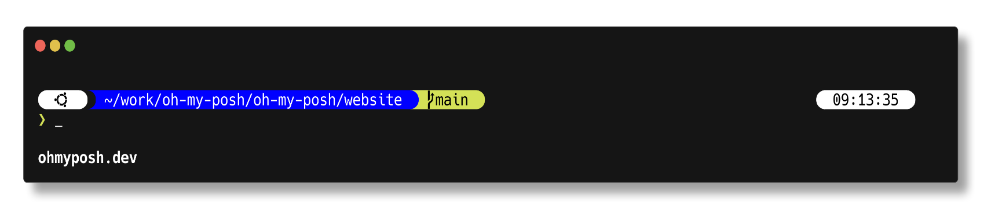](https://github.com/JanDeDobbeleer/oh-my-posh/blob/main/themes/powerlevel10k_modern.omp.json)

[**powerlevel10k\_rainbow**](https://github.com/JanDeDobbeleer/oh-my-posh/blob/main/themes/powerlevel10k_rainbow.omp.json)[**​**](https://ohmyposh.dev/docs/themes#powerlevel10k_rainbow)

[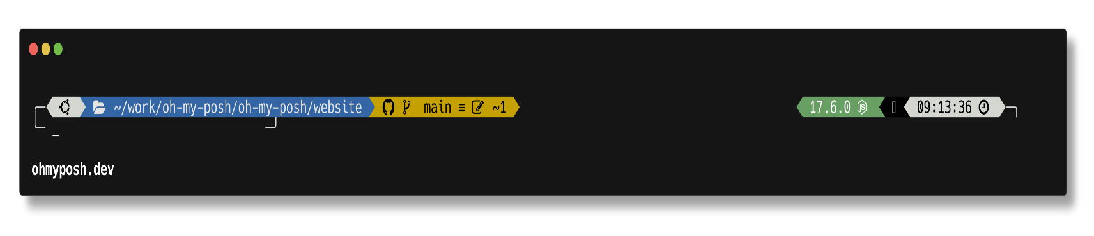](https://github.com/JanDeDobbeleer/oh-my-posh/blob/main/themes/powerlevel10k_rainbow.omp.json)

[**powerline**](https://github.com/JanDeDobbeleer/oh-my-posh/blob/main/themes/powerline.omp.json)[**​**](https://ohmyposh.dev/docs/themes#powerline)

[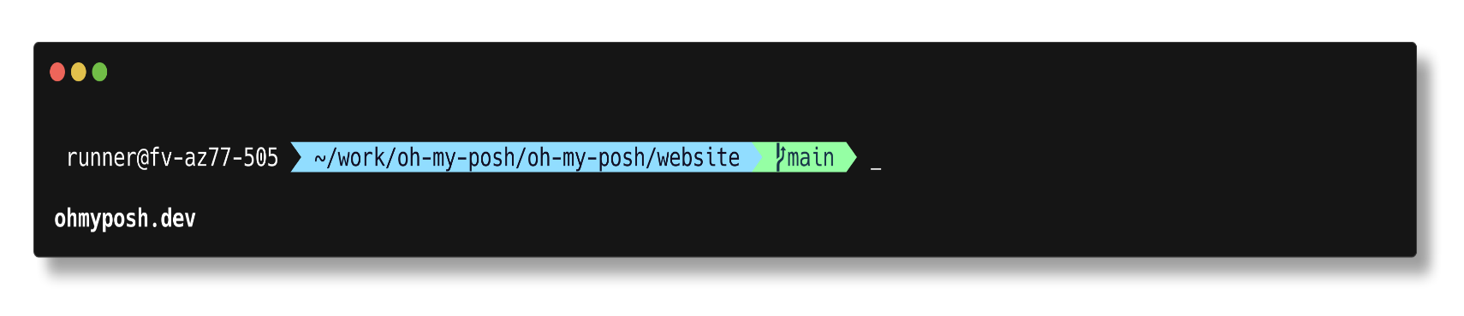](https://github.com/JanDeDobbeleer/oh-my-posh/blob/main/themes/powerline.omp.json)

[**probua.minimal**](https://github.com/JanDeDobbeleer/oh-my-posh/blob/main/themes/probua.minimal.omp.json)[**​**](https://ohmyposh.dev/docs/themes#probuaminimal)

[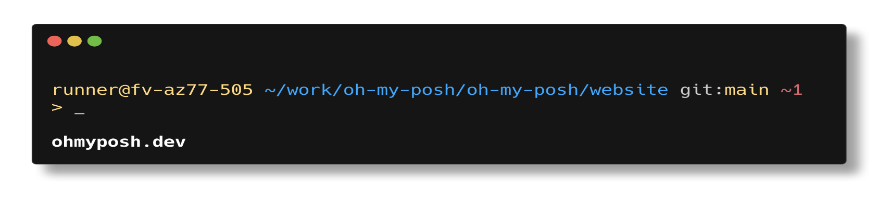](https://github.com/JanDeDobbeleer/oh-my-posh/blob/main/themes/probua.minimal.omp.json)

[**pure**](https://github.com/JanDeDobbeleer/oh-my-posh/blob/main/themes/pure.omp.json)[**​**](https://ohmyposh.dev/docs/themes#pure)

[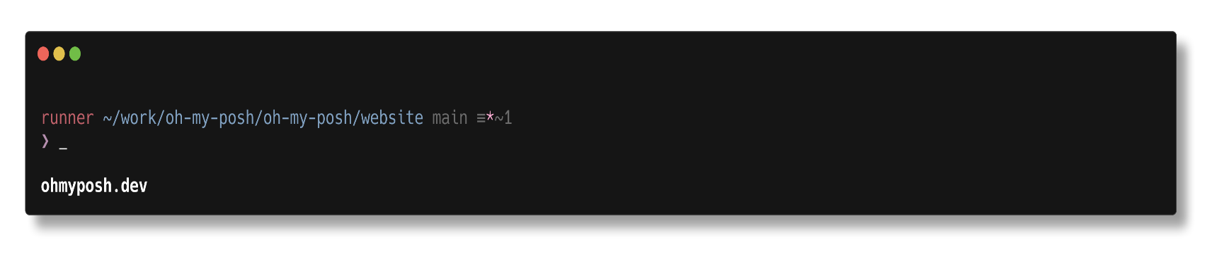](https://github.com/JanDeDobbeleer/oh-my-posh/blob/main/themes/pure.omp.json)

[**quick-term**](https://github.com/JanDeDobbeleer/oh-my-posh/blob/main/themes/quick-term.omp.json)[**​**](https://ohmyposh.dev/docs/themes#quick-term)

[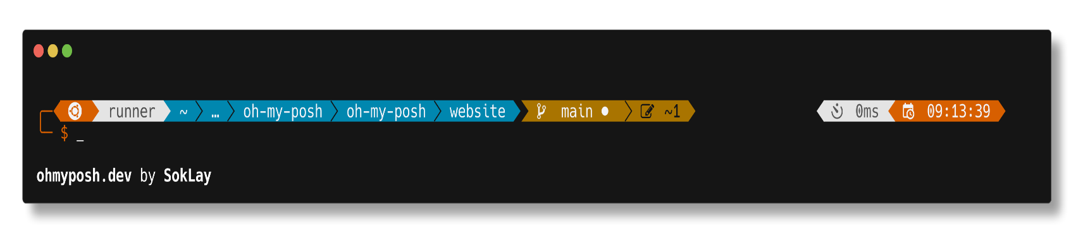](https://github.com/JanDeDobbeleer/oh-my-posh/blob/main/themes/quick-term.omp.json)

[**remk**](https://github.com/JanDeDobbeleer/oh-my-posh/blob/main/themes/remk.omp.json)[**​**](https://ohmyposh.dev/docs/themes#remk)

[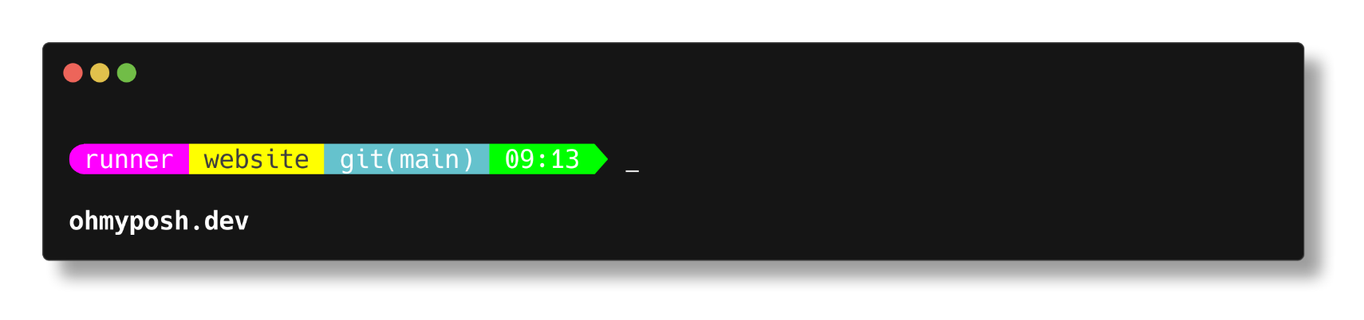](https://github.com/JanDeDobbeleer/oh-my-posh/blob/main/themes/remk.omp.json)

[**robbyrussel**](https://github.com/JanDeDobbeleer/oh-my-posh/blob/main/themes/robbyrussel.omp.json)[**​**](https://ohmyposh.dev/docs/themes#robbyrussel)

[](https://github.com/JanDeDobbeleer/oh-my-posh/blob/main/themes/robbyrussel.omp.json)

[**rudolfs-dark**](https://github.com/JanDeDobbeleer/oh-my-posh/blob/main/themes/rudolfs-dark.omp.json)[**​**](https://ohmyposh.dev/docs/themes#rudolfs-dark)

[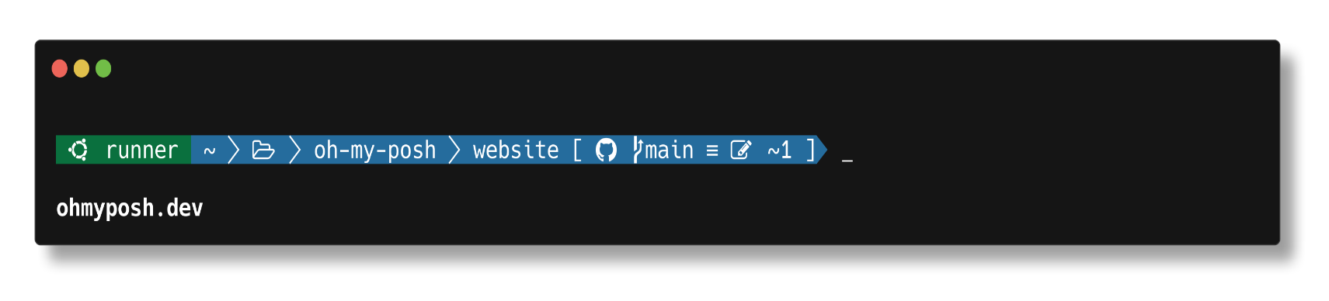](https://github.com/JanDeDobbeleer/oh-my-posh/blob/main/themes/rudolfs-dark.omp.json)

[**rudolfs-light**](https://github.com/JanDeDobbeleer/oh-my-posh/blob/main/themes/rudolfs-light.omp.json)[**​**](https://ohmyposh.dev/docs/themes#rudolfs-light)

[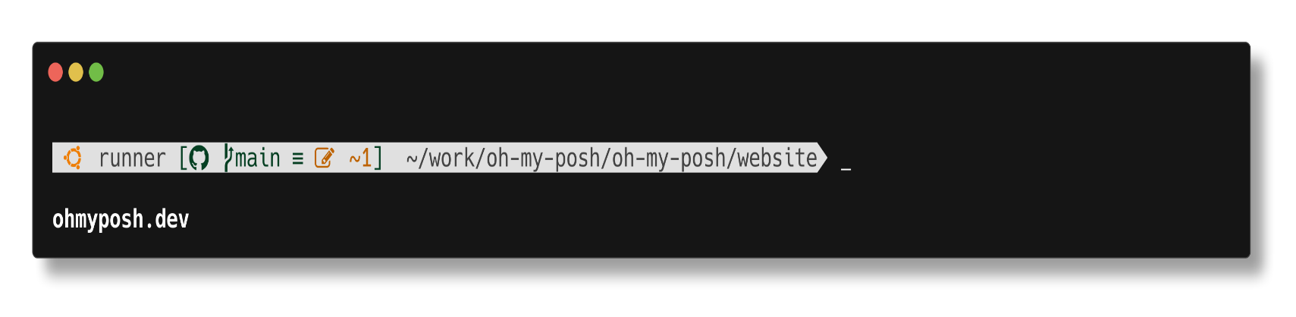](https://github.com/JanDeDobbeleer/oh-my-posh/blob/main/themes/rudolfs-light.omp.json)

[**sim-web**](https://github.com/JanDeDobbeleer/oh-my-posh/blob/main/themes/sim-web.omp.json)[**​**](https://ohmyposh.dev/docs/themes#sim-web)

[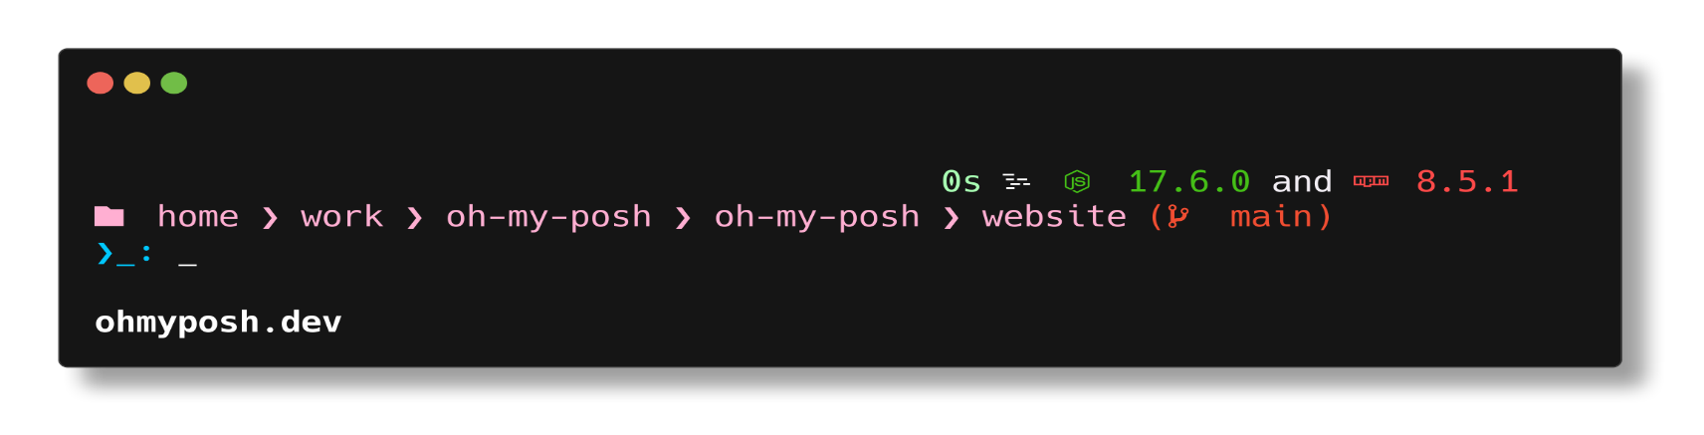](https://github.com/JanDeDobbeleer/oh-my-posh/blob/main/themes/sim-web.omp.json)

[**slim**](https://github.com/JanDeDobbeleer/oh-my-posh/blob/main/themes/slim.omp.json)[**​**](https://ohmyposh.dev/docs/themes#slim)

[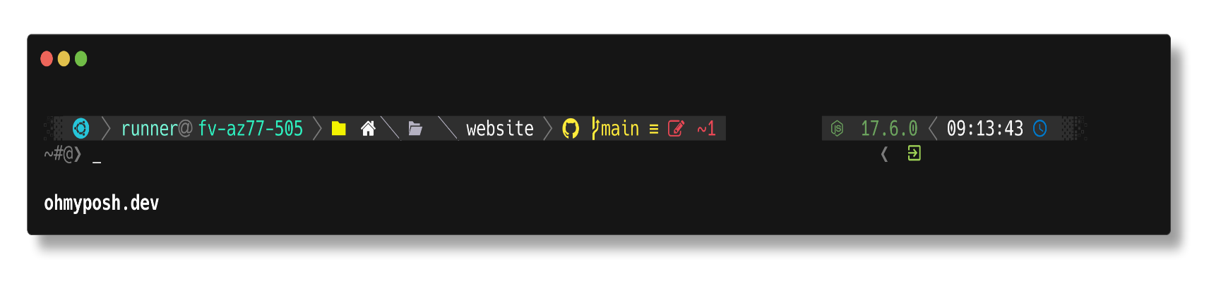](https://github.com/JanDeDobbeleer/oh-my-posh/blob/main/themes/slim.omp.json)

[**slimfat**](https://github.com/JanDeDobbeleer/oh-my-posh/blob/main/themes/slimfat.omp.json)[**​**](https://ohmyposh.dev/docs/themes#slimfat)

[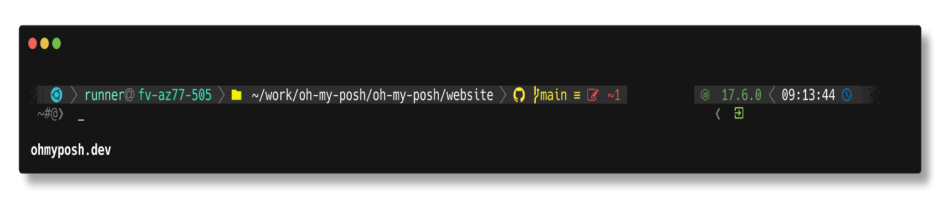](https://github.com/JanDeDobbeleer/oh-my-posh/blob/main/themes/slimfat.omp.json)

[**smoothie**](https://github.com/JanDeDobbeleer/oh-my-posh/blob/main/themes/smoothie.omp.json)[**​**](https://ohmyposh.dev/docs/themes#smoothie)

[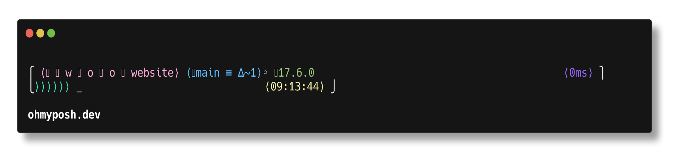](https://github.com/JanDeDobbeleer/oh-my-posh/blob/main/themes/smoothie.omp.json)

[**sonicboom\_dark**](https://github.com/JanDeDobbeleer/oh-my-posh/blob/main/themes/sonicboom_dark.omp.json)[**​**](https://ohmyposh.dev/docs/themes#sonicboom_dark)

[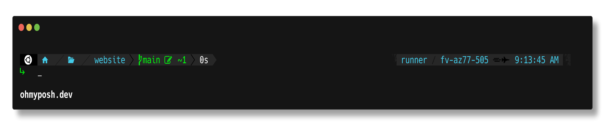](https://github.com/JanDeDobbeleer/oh-my-posh/blob/main/themes/sonicboom_dark.omp.json)

[**sonicboom\_light**](https://github.com/JanDeDobbeleer/oh-my-posh/blob/main/themes/sonicboom_light.omp.json)[**​**](https://ohmyposh.dev/docs/themes#sonicboom_light)

[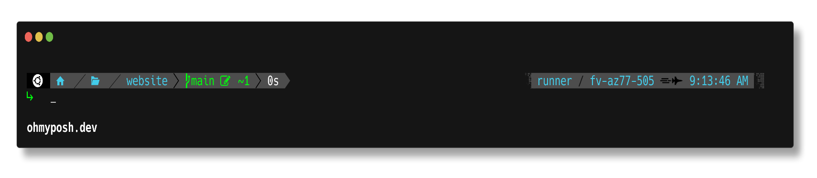](https://github.com/JanDeDobbeleer/oh-my-posh/blob/main/themes/sonicboom_light.omp.json)

[**sorin**](https://github.com/JanDeDobbeleer/oh-my-posh/blob/main/themes/sorin.omp.json)[**​**](https://ohmyposh.dev/docs/themes#sorin)

[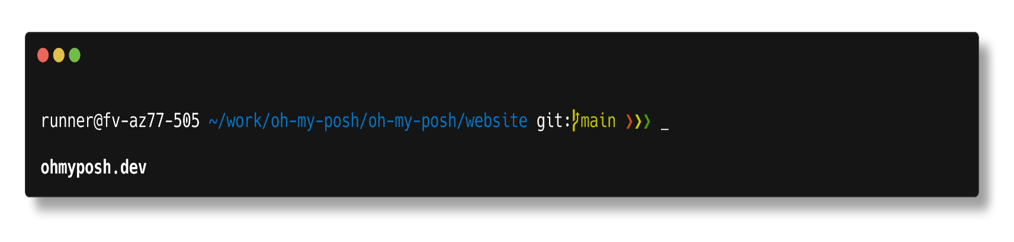](https://github.com/JanDeDobbeleer/oh-my-posh/blob/main/themes/sorin.omp.json)

[**space**](https://github.com/JanDeDobbeleer/oh-my-posh/blob/main/themes/space.omp.json)[**​**](https://ohmyposh.dev/docs/themes#space)

[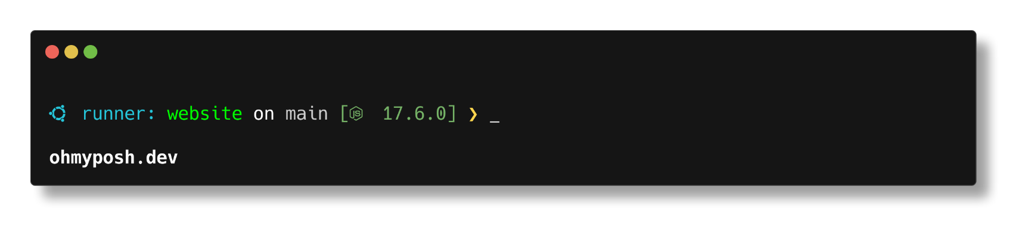](https://github.com/JanDeDobbeleer/oh-my-posh/blob/main/themes/space.omp.json)

[**spaceship**](https://github.com/JanDeDobbeleer/oh-my-posh/blob/main/themes/spaceship.omp.json)[**​**](https://ohmyposh.dev/docs/themes#spaceship)

[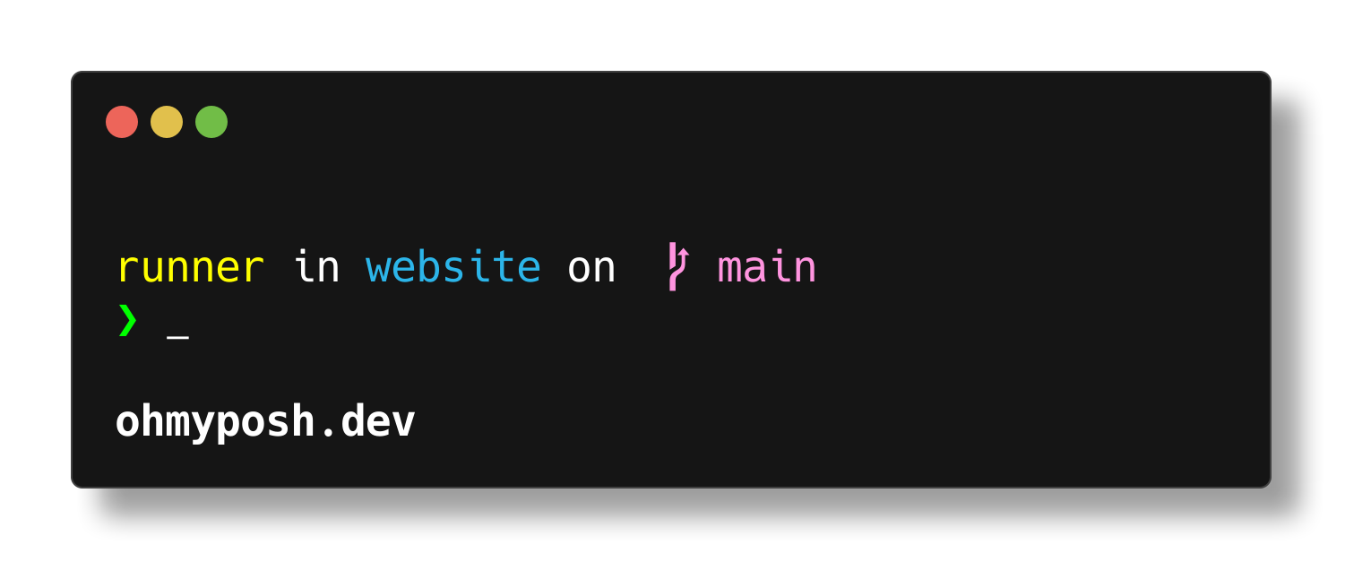](https://github.com/JanDeDobbeleer/oh-my-posh/blob/main/themes/spaceship.omp.json)

[**star**](https://github.com/JanDeDobbeleer/oh-my-posh/blob/main/themes/star.omp.json)[**​**](https://ohmyposh.dev/docs/themes#star)

[](https://github.com/JanDeDobbeleer/oh-my-posh/blob/main/themes/star.omp.json)

[**stelbent-compact.minimal**](https://github.com/JanDeDobbeleer/oh-my-posh/blob/main/themes/stelbent-compact.minimal.omp.json)[**​**](https://ohmyposh.dev/docs/themes#stelbent-compactminimal)

[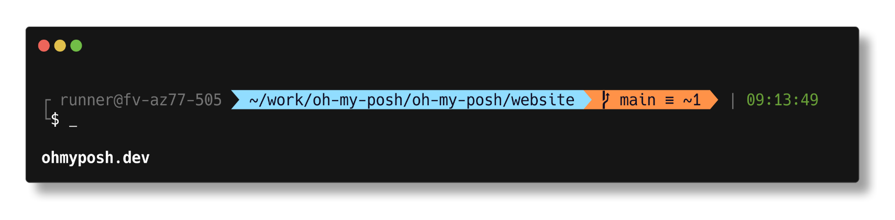](https://github.com/JanDeDobbeleer/oh-my-posh/blob/main/themes/stelbent-compact.minimal.omp.json)

[**stelbent.minimal**](https://github.com/JanDeDobbeleer/oh-my-posh/blob/main/themes/stelbent.minimal.omp.json)[**​**](https://ohmyposh.dev/docs/themes#stelbentminimal)

[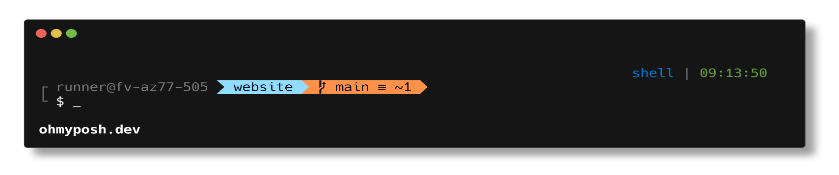](https://github.com/JanDeDobbeleer/oh-my-posh/blob/main/themes/stelbent.minimal.omp.json)

[**takuya**](https://github.com/JanDeDobbeleer/oh-my-posh/blob/main/themes/takuya.omp.json)[**​**](https://ohmyposh.dev/docs/themes#takuya)

[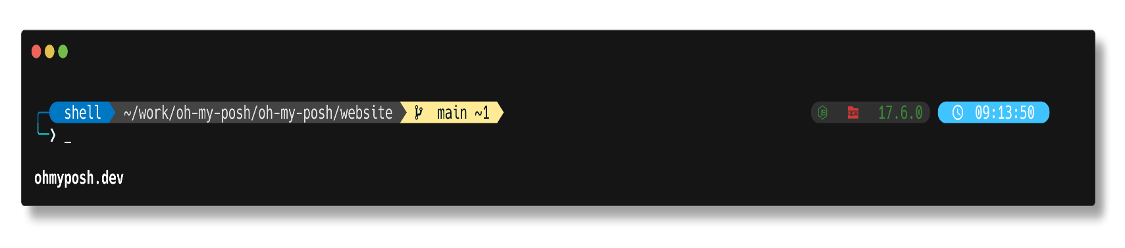](https://github.com/JanDeDobbeleer/oh-my-posh/blob/main/themes/takuya.omp.json)

[**the-unnamed**](https://github.com/JanDeDobbeleer/oh-my-posh/blob/main/themes/the-unnamed.omp.json)[**​**](https://ohmyposh.dev/docs/themes#the-unnamed)

[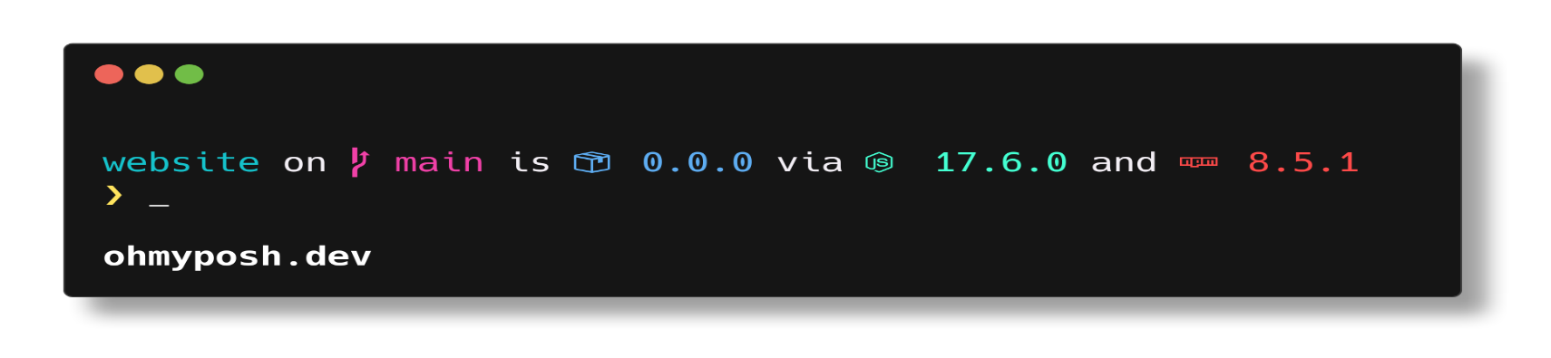](https://github.com/JanDeDobbeleer/oh-my-posh/blob/main/themes/the-unnamed.omp.json)

[**thecyberden**](https://github.com/JanDeDobbeleer/oh-my-posh/blob/main/themes/thecyberden.omp.json)[**​**](https://ohmyposh.dev/docs/themes#thecyberden)

[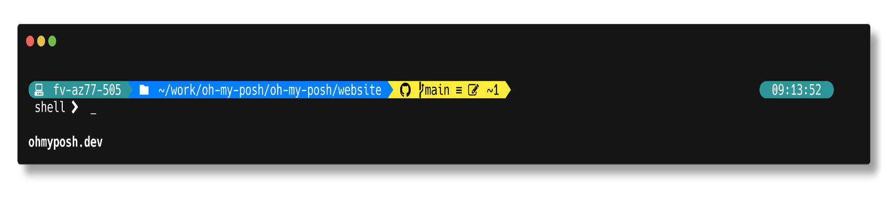](https://github.com/JanDeDobbeleer/oh-my-posh/blob/main/themes/thecyberden.omp.json)

[**tiwahu**](https://github.com/JanDeDobbeleer/oh-my-posh/blob/main/themes/tiwahu.omp.json)[**​**](https://ohmyposh.dev/docs/themes#tiwahu)

[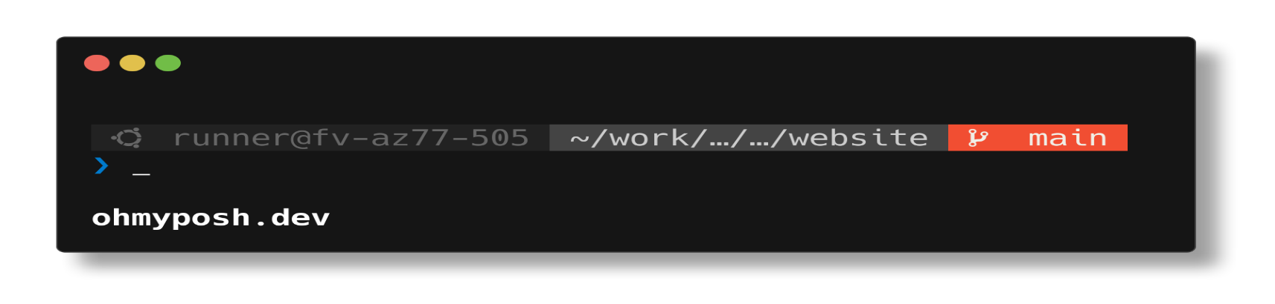](https://github.com/JanDeDobbeleer/oh-my-posh/blob/main/themes/tiwahu.omp.json)

[**tokyo**](https://github.com/JanDeDobbeleer/oh-my-posh/blob/main/themes/tokyo.omp.json)[**​**](https://ohmyposh.dev/docs/themes#tokyo)

[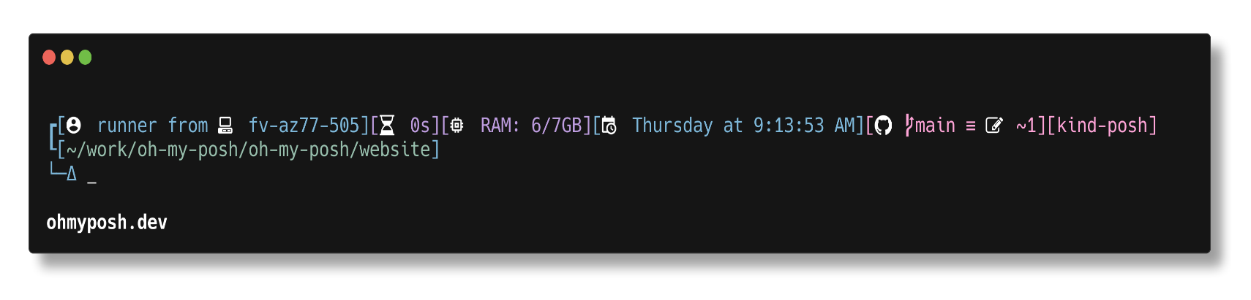](https://github.com/JanDeDobbeleer/oh-my-posh/blob/main/themes/tokyo.omp.json)

[**tokyonight\_storm**](https://github.com/JanDeDobbeleer/oh-my-posh/blob/main/themes/tokyonight_storm.omp.json)[**​**](https://ohmyposh.dev/docs/themes#tokyonight_storm)

[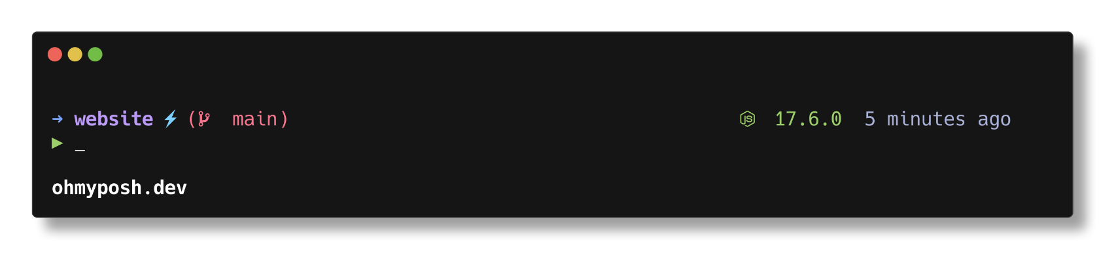](https://github.com/JanDeDobbeleer/oh-my-posh/blob/main/themes/tokyonight_storm.omp.json)

[**tonybaloney**](https://github.com/JanDeDobbeleer/oh-my-posh/blob/main/themes/tonybaloney.omp.json)[**​**](https://ohmyposh.dev/docs/themes#tonybaloney)

[](https://github.com/JanDeDobbeleer/oh-my-posh/blob/main/themes/tonybaloney.omp.json)

[**uew**](https://github.com/JanDeDobbeleer/oh-my-posh/blob/main/themes/uew.omp.json)[**​**](https://ohmyposh.dev/docs/themes#uew)

[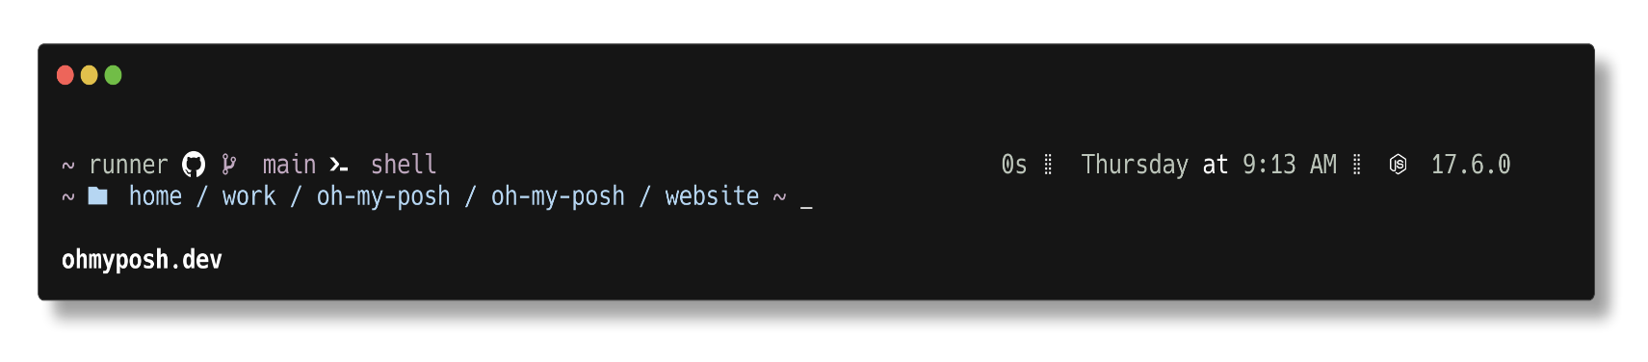](https://github.com/JanDeDobbeleer/oh-my-posh/blob/main/themes/uew.omp.json)

[**unicorn**](https://github.com/JanDeDobbeleer/oh-my-posh/blob/main/themes/unicorn.omp.json)[**​**](https://ohmyposh.dev/docs/themes#unicorn)

[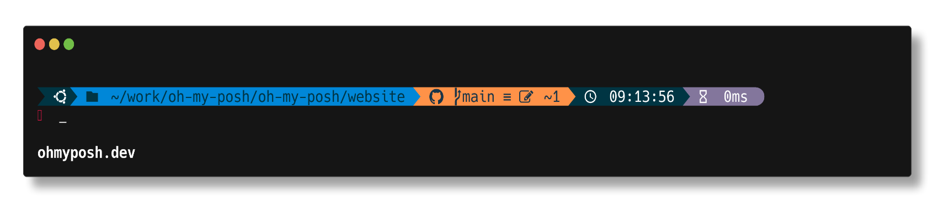](https://github.com/JanDeDobbeleer/oh-my-posh/blob/main/themes/unicorn.omp.json)

[**velvet**](https://github.com/JanDeDobbeleer/oh-my-posh/blob/main/themes/velvet.omp.json)[**​**](https://ohmyposh.dev/docs/themes#velvet)

[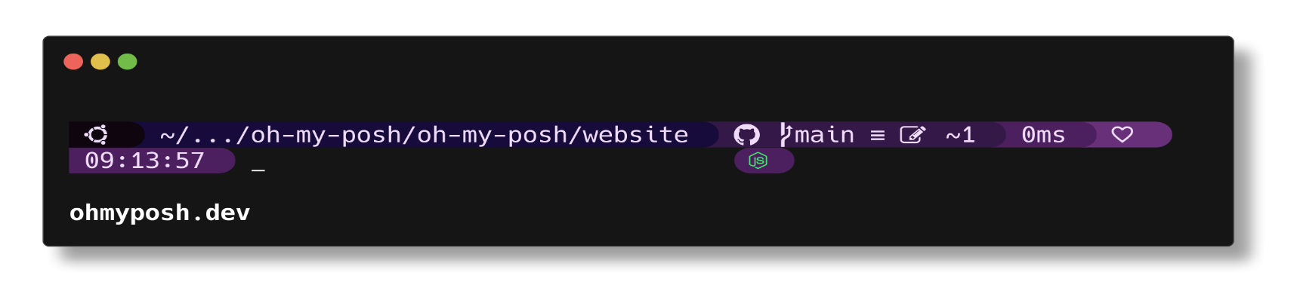](https://github.com/JanDeDobbeleer/oh-my-posh/blob/main/themes/velvet.omp.json)

[**wholespace**](https://github.com/JanDeDobbeleer/oh-my-posh/blob/main/themes/wholespace.omp.json)[**​**](https://ohmyposh.dev/docs/themes#wholespace)

[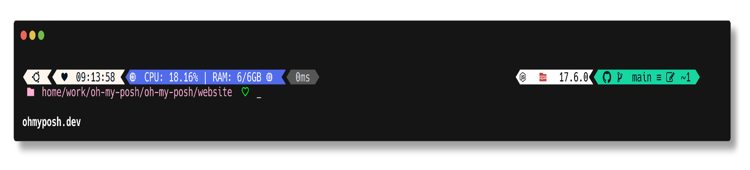](https://github.com/JanDeDobbeleer/oh-my-posh/blob/main/themes/wholespace.omp.json)

[**wopian**](https://github.com/JanDeDobbeleer/oh-my-posh/blob/main/themes/wopian.omp.json)[**​**](https://ohmyposh.dev/docs/themes#wopian)

[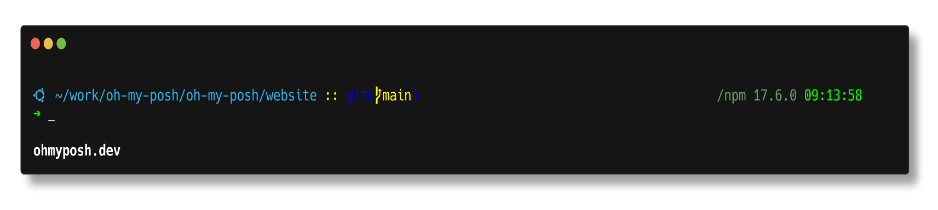](https://github.com/JanDeDobbeleer/oh-my-posh/blob/main/themes/wopian.omp.json)

[**xtoys**](https://github.com/JanDeDobbeleer/oh-my-posh/blob/main/themes/xtoys.omp.json)[**​**](https://ohmyposh.dev/docs/themes#xtoys)

[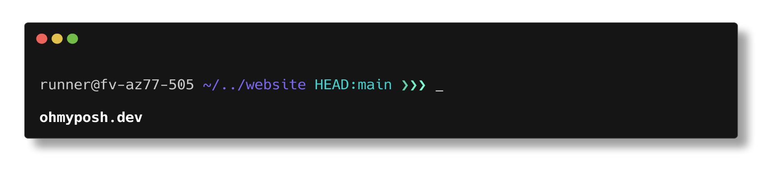](https://github.com/JanDeDobbeleer/oh-my-posh/blob/main/themes/xtoys.omp.json)

[**ys**](https://github.com/JanDeDobbeleer/oh-my-posh/blob/main/themes/ys.omp.json)[**​**](https://ohmyposh.dev/docs/themes#ys)

[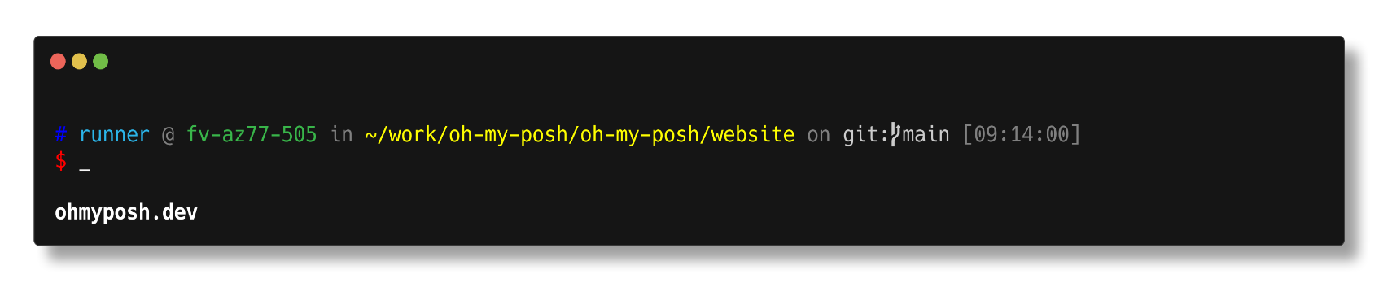](https://github.com/JanDeDobbeleer/oh-my-posh/blob/main/themes/ys.omp.json)

[**zash**](https://github.com/JanDeDobbeleer/oh-my-posh/blob/main/themes/zash.omp.json)[**​**](https://ohmyposh.dev/docs/themes#zash)

